Firmware and Software for an Integrated Electrophysiology Data Acquisition and Stimulation System

Kyle D. Batzer, M.S.E.

Western Michigan University, 2013

This thesis describes the firmware and software design for a prototype electrophysiology experimentation system. The overall system, built on the work of previous students and developed with fellow graduate student Mr. Donovan Squires, provides eight channels of acquisition and four channel of arbitrary waveform generation for stimulation of biological systems. In order to show the performance of the system, a common electrophysiology experiment was performed on the giant axon of an earthworm and the results were compared to previously validated systems. The developed system is intended to support future work at the Neurobiology Engineering Laboratory at Western Michigan University.

The user of the system is provided high-level control, experimentation scripting, and data visualization through use of a custom PC application. Real-time operations, such as data capture using an analog-to-digital converter and stimulation waveform output to a digital-to-analog converter, are implemented with a field-programmable gate array (FPGA). Domain specific support for -10mV to 10mV acquisition levels and differential waveform generation between -15V to 15V is provided via a custom printed circuit board when utilizing previously developed amplification and filtering circuitry.

Firmware and Software for an Integrated Electrophysiology Data Acquisition and Stimulation System

by

Kyle D. Batzer

A thesis submitted to the Graduate College

in partial fulfillment of the requirements

for the Degree of Master of Science in Engineering (Computer)

Electrical and Computer Engineering

Western Michigan University

December 2013

Thesis Committee:

Damon A. Miller, Ph.D., Chair

Bradley J. Bazuin, Ph.D.

Frank L. Severance, Ph.D.

Copyright © 2013 by Kyle D. Batzer.

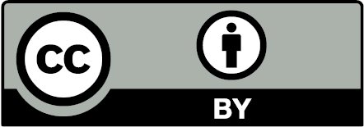

Except where otherwise noted, this work is licensed under the Creative Commons Attribution 3.0 Unported License. To view a copy of this license, visit <http://creativecommons.org/licenses/by/3.0/>.

Foreword is Copyright© 2013 by Damon A. Miller. All rights reserved.

Some names in this thesis are trademarks. Lack of trademark symbol does not imply that a name is not a trademark.

# ACKNOWLEDGMENTS

I would like to thank Dr. Miller, Dr. Severance, and Dr. Bazuin for their guidance and support throughout the project, even well in advance of my related senior design team project. I am also grateful for the support and contributions of doctoral students Michael Ellinger and John Stahl.

I thank Donovan Squires for his work on the Data Acquisition and Stimulation System hardware. It was a pleasure working alongside him for much of the project and I am very happy with what we were able to accomplish.

I thank my wife Kayla for supporting me through the effort, being patient with the long hours, and giving me a solid foundation on which to stand.

Kyle D. Batzer

# FOREWORD

This thesis and the companion Master of Science in Electrical Engineering thesis by Mr. Donovan Squires describe a complete hardware and software instrumentation system for conducting electrophysiology experiments. The developed system features multiple channels that can be used for measurement and stimulation of biological electrical activity. These theses represent the culmination of many previous projects in the Western Michigan University Neurobiology Engineering Laboratory. This foreword provides a brief history of those previous projects to provide context for these two theses.

The original motivation for this line of research was the availability of microelectrode arrays (MEAs) from companies such as Multi Channel Systems (www.multichannelsystems.com). MEAs are essentially culture dishes with an array of implanted electrodes that enable monitoring and stimulation of neuron and neuronal network electrical activity. Reference [] provides an excellent overview of studying learning in neuronal networks using MEAs. I was first introduced to MEAs via an article provided by Dr. John Gesink, Emeritus Chair of the WMU Department of Electrical Engineering. My first steps into this area included submission of an unfunded grant *From Artificial to Naturally Intelligent Systems: Computing with Neuron Cell Cultures* and auditing Dr. John Jellies' outstanding Advanced Neurobiology course in the Spring 2006 semester.

After discussions with Dr. Frank Severance, we decided to start a new laboratory to conduct research using MEAs, and I subsequently visited with Mr. Alex Cadotte at Dr. Thomas DeMarse's lab at the University of Florida to learn more about these devices, including efforts to use neuronal networks as an intelligent closed loop controller [, ]. A WMU Faculty Research and Creative Activities Support Fund grant, myself, Dr. Gesink, Dr. Severance, and the WMU Department of Electrical and Computer Engineering provided funds for cell culture equipment and supplies and instrumentation components. The WMU College of Engineering and Applied Sciences configured a laboratory for cell culture work and the Neurobiology Engineering Laboratory was born. Graduate student Mr. Michael Ellinger led the challenging effort to successfully culture the first cells in the lab in Summer 2008 [14]. Establishing a cell culturing capability relied on help from many people, most notably Biological Sciences graduate student Sr. John-Mary Vianney and her advisor Dr. John Spitsbergen.

In 2007, two senior design groups [, ] developed an initial design for the instrumentation system based on the research literature (including the key references [, ]) and a commercial system from Multi Channel Systems. In particular, [] identified challenges and solutions with recording and stimulating using the same electrode. A third senior design group [] continued this effort, breadboarding a single analog input channel and an associated digital control circuit. Mr. John Stahl conducted research on the noise characteristics of the analog input channel, building a complete analog/digital two channel prototype []. Mr. Stahl then designed a printed circuit board implementation for two analog input channels. A fourth senior design group [] made significant progress on both the instrumentation system hardware and software, including development of a printed circuit board implementation of two analog input channels with the associated digital control circuit. A fifth senior design group [] worked on this system with a focus of using an FPGA based solution for data acquisition and control via a computer. Mr. Squires, working with Mr. Stahl, built on these previous accomplishments to produce the instrumentation design presented in this thesis. His design features a modular system consisting of a “mother board" into which up to eight analog input channel cards (designed by Mr. Stahl) can be inserted. Mr. Batzer, leveraging his previous work as a member of the fourth senior design group, completed the design of an FPGA based solution for data acquisition and control of the instrumentation system via a computer, including a scripting language, as his thesis. A key laboratory accomplishment was using the developed instrumentation system to conduct a standard experiment that measures earthworm giant axon nerve impulses [, , , ] as described in this thesis.

I thank the many students that have worked in the lab over the years. I also thank my colleagues for their unselfish help in these projects, and in particular Dr. Frank Severance, who co-directs the lab, and Drs. Bazuin and Gesink. Finally, I thank the WMU College of Engineering and Applied Sciences, the Department of Electrical and Computer Engineering, the Lee Honors College, the Office of the Vice President for Research, and the NASA Michigan Space Grant Consortium for supporting the work of the Neurobiology Engineering Laboratory.

Dr. Damon A. Miller

Associate Professor of Electrical and Computer Engineering

Western Michigan University

Co-Director, WMU Neurobiology Engineering Laboratory

Kalamazoo, MI

May 2013

TABLE OF CONTENTS

ACKNOWLEDGMENTS ii

FOREWORD iii

LIST OF TABLES x

LIST OF FIGURES xii

CHAPTER

1. Introduction 1

2. Specifications 2

3. Terminology 4

Table of Contents - Continued

CHAPTER

4. System Design: Software and Firmware 5

4.1. Data Flow Analysis 7

4.2. RTSC FPGA Configuration 12

4.2.1. Control Registers 12

4.2.2. Analog-to-Digital Converter Module 14

4.2.3. Digital-to-Analog Converter Module 20

4.2.4. RS232 Module 28

4.2.5. RAM Module 33

4.2.6. USB Module 38

4.2.7. Command Handler Module 42

4.3. RTSC Cypress EZ-USB 46

4.3.1. FPGA Programming 46

4.3.2. USB Data Transfers 46

4.4. Data Acquisition and Stimulation Control Center 48

4.4.1. PC Application Design 49

4.4.2. RTSC Application Programming Interface (API) 53

Table of Contents – Continued

CHAPTER

5. Electrophysiology Application 61

5.1. Earthworm Setup 63

5.2. Chloriding Silver Wire 64

5.3. Earthworm Experiment Procedure 65

5.3.1. Earthworm Dissection 65

5.3.2. Electrical Setup 66

5.3.3. Software Setup 66

5.3.4. Stimulation and Recording 67

5.4. Results 67

6. Specifications Review 71

7. Conclusions 75

Table of Contents - Continued

APPENDICES

A. GitHub Repository 79

B. Programming FPGA 81

C. Programming Cypress EZ-USB (CY7C68013A) 84

D. DASCC Scripting Amplitude 86

E. Earthworm Script and Waveform 88

F. DASCC Scripting Commands 90

G. RTSC FPGA Configuration - Code 93

H. Data Acquisition and Stimulation Control Center - Code 239

**Error! Hyperlink reference not valid.**272REFERENCES 272

# LIST OF TABLES

1: Channel Configuration Registers 13

2: Stimulation Register 13

3: Acquisition Register 13

4: Analog-to-Digital Converter Module Signals 16

5: Acquisition Packet Structure 18

6: DAC Module Signals 22

7: Memory Locations for Stimulation Waveforms 27

8: RS232 Module Signals 30

9: RAM Module Signals 36

10: USB Module Signals 40

11: Command Handler Module Signals 44

12: Digilent Firmware Vs. Custom Firmware USB Configuration 47

List of Tables - Continued

13: Set Channel Configuration Request 53

14: Set Channel Configuration Reply 54

15: Get Channel Configuration Request 54

16: Get Channel Configuration Reply 54

17: Set Acquisition Register Request 55

18: Set Acquisition Register Reply 55

19: Get Acquisition Register Request 55

20: Get Acquisition Register Reply 56

21: Set Waveform Request 56

22: Set Waveform Reply 57

23: Get Waveform Request 57

24: Get Waveform Reply 58

25: Set Stimulation Register Request 59

26: Set Stimulation Register Reply 59

27: Get Stimulation Register Request 59

28: Get Stimulation Register Reply 60

29: Buffer Fill Time 77

30: DASCC Scripting Amplitude Hex Value Table 87

# LIST OF FIGURES

1: The Data Acquisition and Stimulation System. Figure by D. Squires [15]. 6

2: Acquisition Data Flow 7

3: Stimulation Data Flow 10

4: FPGA Top-Level Configuration 12

5: AD7606 Serial Read Operation (Figure 6 from [20]) 14

6: ADC Module Block Diagram 17

7: ADC Module Flow Chart 17

8: ADC Capture Module Flow Chart 19

9: AD5678 Serial Write (Figure 2 from [21]) 21

10: Block diagram of the DAC module IO and internal modules 23

11: DAC_Init Flow Chart 24

12: DAC_Channel Flow Chart 26

13: SPI Transmit Flow Chart 28

14: RS232 8-bit Transaction 28

15: RS232 Block Diagram 29

16: TX Module Flow Chart 31

17: RX Module Flow Chart 32

18: MT45W8MW16BGX Asynchronous Read Operation (Figure 5 from [22]) 33

List of Figures - Continued

19: MT45W8MW16BGX Asynchronous Write Operation (Figure 6 from [22]) 34

20: RAM Module Block Diagram 35

21: RAM Module Flow Chart 37

22: Synchronous Slave FIFO (as described in [23]) 38

23: USB Module Block Diagram 39

24: USB Module Flow Chart 41

25: Command Handler Module Block Diagram 43

26: Command Handler Flow Chart 45

27: Data Acquisition and Stimulation Control Center 48

28: DASCC class diagram 49

29: DASCC Channel Configuration 49

30: DASCC Graphing View 50

31: DASCC Scripting View 51

32: Cross section of an earthworm adapted from [13, 18]. 62

33: Connections between the DASS and an earthworm. Illustration by D. Squires [15]. 63

34: DASS connected in parallel with a previously validated recording systeIllustration by D. Squires [15]. 64

35: Picture of the Data Acquisition and Stimulation System connected in parallel with a previously validated recording system 68

36: Earthworm response to 2.0V stimulation pulse with data recorded by an Oscilloscope and the Data Acquisition and Stimulation System 69

37: Earthworm response to 3.5V stimulation pulse with data recorded by an Oscilloscope and the Data Acquisition and Stimulation System 70

38: Digilent Adept software used for programming the FPGA 82

# Introduction[1]

An Integrated Electrophysiology Data Acquisition and Stimulation System to support electrophysiology research has been developed by building on previous work at WMU [, , , , ], studying commercial systems [], and reviewing the research literature [, , ]. The developed prototype provides a real-time platform for measurement and stimulation of biological electrical activity and a PC application for controlling the real-time platform and visualizing cellular activity. The system can accommodate up to eight measurement channels and four stimulation channels, and the design can be expanded for up to 60 channels to support future research at the Western Michigan University (WMU) Neurobiology Engineering Laboratory.

The developed prototype is viable for a wide array of electrophysiology experiments, completely fulfilling the instrumentation needs of [, , ] and partially fulfilling the instrumentation needs of [, , ]. In particular, a standard electrophysiology experiment was performed on earthworm giant axon potentials to validate system functionality. The prototype is also intended for studying software and hardware principles required for performing research using cells cultured on a Microelectrode Array (MEA), e.g. [16]. A cell culture protocol has been developed [] and previous work on such a system [, , ], including low noise amplification [], has been completed. Initial analytical algorithms have also been developed [].

# Specifications[2]

The Data Acquisition and Stimulation System (DASS) is expected to provide the following functionality:

1. Provide a platform for performing electrophysiology experiments with earthworms as described in [, ]
   1. Produce a voltage-controlled square wave stimulation pulse with widths from 0.01ms to 100ms and amplitudes from 0.1V to 10V
   2. Produce single stimulation pulses or multiple pulses at rates from 1Hz to 10Hz
   3. Provide at least one differential recording channel
   4. Record an action potential voltage from the time of a stimulation pulse for a minimum duration of 20ms
   5. Plot the recorded voltage
   6. Store the recorded voltage to a non-proprietary, standard file format
2. Provide a platform for stimulation and recording of neuron cell culture electrical activity via MEA electrodes
   1. Provide at least four recording channels
   2. Store data from recording channels continuously
   3. Provide at least four voltage-controlled arbitrary stimulation channels
   4. Output single-ended stimulation signals on recording electrodes and add culture voltage offset to the stimulation signal
   5. Provide an interface that can specify stimulation waveforms, locations, and intervals that can be updated based on data from the recording electrodes
3. Utilize Low-Noise Amplifier described in []
   1. Connect to each Low-Noise Amplifier channel with a PCI-Express card edge connector
   2. Provide ±7V to ±15V analog voltage supplies and ground via the card edge connector
   3. Provide ability to independently switch four digital inputs for each channel, 0IH = 0.8V and 1IL = 2.4V
   4. Route differential analog input to the card edge connector for each channel
   5. Convert the 20Hz to 14.6kHz analog output signal [] to digital samples
   6. Route a single-ended stimulation signal to each channel

# Terminology

**Data Acquisition and Stimulation System (DASS)****[3]:** System intended for electrophysiology experiments described in this thesis and corresponding thesis []. The DASS includes all hardware, software, and firmware.

**Real Time System Controller (RTSC)3:** Subsystem that implements the real-time functions of the system. It consists of a Digilent® Nexys2™ development board [] with custom firmware.

**Electrophysiology Interface3:** Subsystem that provides the RTSC with an interface to biological systems, as described in [].

**Preamp3:** Low noise instrumentation amplifier with stimulation dc bias addition for MEA experiments, described in [,15].

**Data Acquisition and Stimulation Control Center (DASCC)3:** PC application, described in this thesis, for controlling and transferring data to and from the RTSC.

**VHDL:** Very High Speed Integrated Circuits (VHSIC) Hardware Description Language

**Module:** Used in the section of this document to describe a functional component within the VHDL hierarchy.

# System Design: Software and Firmware

The developed Data Acquisition and Stimulation System (DASS) provides multi-channel data acquisition and arbitrary waveform generation for performing electrophysiology experiments. Figure 1 provides a top-level overview of the major components.

The first major component of the system is a standard Windows PC. A custom PC application was developed that provides a user interface for controlling the Real Time System Controller (RTSC) over an RS232 interface. Acquired data is captured and logged over a USB interface. Once captured to file, acquired data can be graphed and exported to .csv format for analysis in other tools (e.g. Matlab, Excel).

The second major component is the Real Time System Controller (RTSC). It is a Digilent® Nexys 2™ FPGA development board [] with custom FPGA firmware that provides real-time control of four digital-to-analog converter (DAC) channels and eight analog-to-digital converter (ADC) channels for waveform generation and acquisition of biological signals. Unique arbitrary waveforms can be loaded from the PC application into the SDRAM for each of the four channels and any combination of the channels output simultaneously.

The third major component is the Electrophysiology Interface board developed in [15] to provide the DAC, ADC, eight PreAmp interfaces, and differential output amplification. The PreAmp and differential output provide signal levels required for work with biological systems.



Figure 1: The Data Acquisition and Stimulation System. Figure by D. Squires [15].

## Data Flow Analysis

**Acquisition**

One of the primary features of the Data Acquisition and Stimulation System is to sample multiple analog channels simultaneously and route that data to file on a PC for analysis. Figure 2 provides an overview of the acquisition data flow. Note that due to the non-real time characteristics of a Windows PC, it is necessary to buffer data where possible to limit susceptibility to times when the operating system is servicing another process.

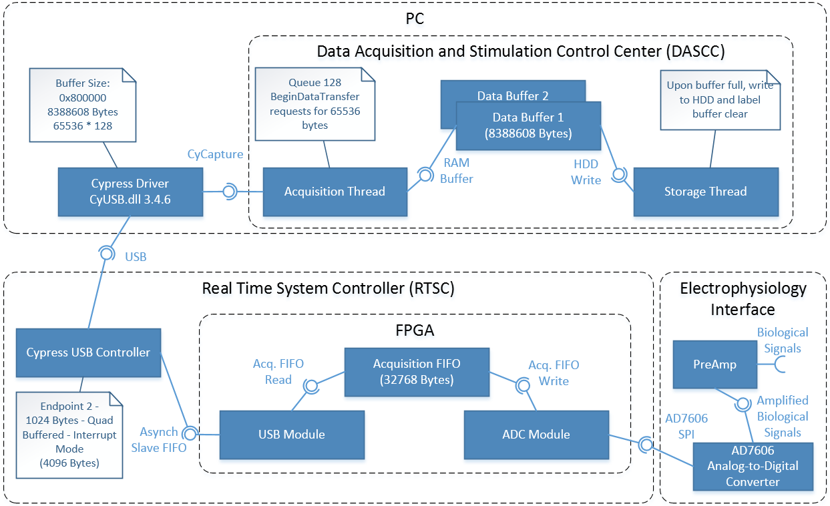

Figure 2: Acquisition Data Flow

The biological signal of interest is connected to the PreAmp. The PreAmp provides biological signal amplification (1000V/V gain) and filtering (passband between 20Hz and 14.6 kHz). The PreAmp accepts inputs in the range of -10mV to 10mV, which will result in -10V to 10V after applying the 1000V/V gain. The amplified biological signal is sampled by the AD7606 at a 44.1 kHz rate with 16-bit resolution. The raw ADC data bandwidth over the AD7606 SPI interface is 0.7056 Mbytes/s, calculated as follows:

$Raw ADC Data=\frac{8 channels*2 bytes/channel*44100Hz}{1000000}=0.7056 Mbytes/s$.

The ADC Module takes this raw ADC data and packetizes it, adding meta-data to assist in detecting and validating the acquired data one it reaches the DASCC. This additional overhead results in 32 bytes for the eight channels of acquired data and a packetized ADC data bandwidth of 1.4112 Mbytes/s, calculated as follows:

$Packetized ADC Data= \frac{32 bytes*44100Hz}{1000000}=1.4112 Mbytes/s$.

The ADC module then passes the data into the Acquisition FIFO using the Acquisition FIFO Write interface, one byte at a time. The Acquisition FIFO provides a total of 32768 bytes of buffering for acquired data. From here the USB Module will read data from the Acquisition FIFO using the Acquisition FIFO Read interface and write it to the Cypress USB Controller using the Asynch Slave FIFO interface.

The Cypress USB Controller provides four FIFOs, each able to hold 1024 bytes. Upon filling one of these FIFOs, a USB interrupt mode transaction is started and the FIFOs contents are transmitted to the PC while another FIFO is used to capture incoming data over the Asynch Slave FIFO interface. Interrupt mode USB transfers have a guaranteed chance to be serviced every USB micro-frame (125 micro-seconds). The theoretical throughput for high-speed USB 2.0 interrupt transactions of 8.192 Mbytes/s is sufficient for handling the packetized ADC Data rate of 1.4112 Mbytes/s and is calculated as follows:

$Interrupt Mode Bandwidth=1024 bytes* \frac{1}{125 microseconds}=8.192 Mbytes/s$.

On the PC, received USB data is initially buffered by the Cypress driver. The maximum buffer size has been increased to 8388608 bytes (65536 bytes * 128), to support the maximum requested bytes by the DASCC (128 asynchronous transfers of 65536 bytes).

The DASCC has an acquisition thread, dual 8388608 byte memory buffers, and a storage thread. The acquisition thread queues up 128 reads from the Cypress driver of 65536 bytes and then waits for the Cypress driver to signal that the data is available. When available, the 65536 bytes are read into a memory buffer and another read is queued, keeping the number of queued reads at 128. The memory buffer is filled until it reaches 8388608 bytes, and then the storage thread writes the buffer to hard drive and the acquisition thread begins to fill the second memory buffer. This dual buffer concept is generally referred to as a ping-pong buffer.

**Stimulation**

Another major feature of the Data Acquisition and Stimulation System is multi-channel arbitrary waveform generation. Figure 3 provides an overview of the stimulation data flow. Note that this includes both loading the waveform from a file on the PC to RAM on the RTSC and outputting a differential arbitrary waveform.

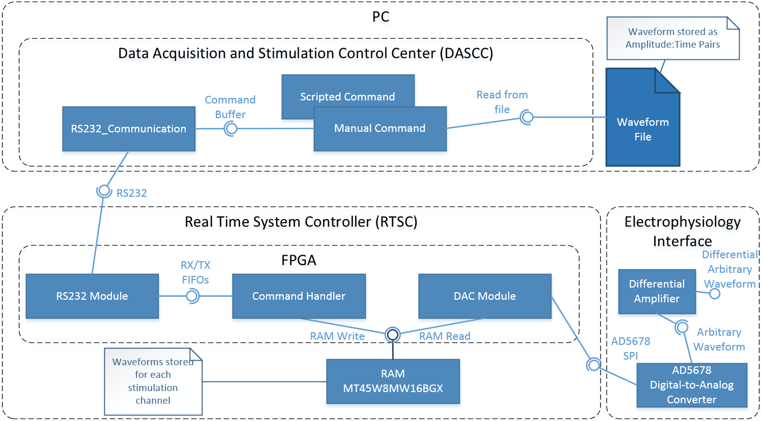

Figure 3: Stimulation Data Flow

Waveform descriptions must first be loaded into RAM on the RTSC before the stimulation channels can output the described arbitrary waveform. This process begins with reading in the waveform file with the DASCC and sending it out RS232, either from a scripted or manual command. The waveform is stored as amplitude to set and amount of time to maintain the amplitude. For more details on the amplitude:time pairs see the DAC Channel Module Implementation section of this document.

On the FPGA, the RS232 Module receives the waveform description via the Set Waveform reply RTSC API command. The Command Handler reads the command from the RX FIFO and writes the waveform description to the respective channel RAM location (see Table 7: Memory Locations for Stimulation Waveforms). The Command Handler then places the Set Waveform reply RTSC API command into the TX FIFO, from where the RS232 Module transmits the reply back to the DASCC.

Once a waveform has been loaded for each desired channel, the RTSC can be commanded to begin outputting arbitrary waveforms on any combination of the four supported DAC channels simultaneously. The DAC Module contains separate logic for each DAC channel, each of which can be idle, outputting its waveform once (single stimulation), or outputting its waveform repeatedly (multi-stimulation). Upon the defined time for a sample elapsing, the amplitude is set for the next sample via command over the AD5678 SPI interface to the AD5678. From there, the DAC output passes through a differential amplifier, resulting in a single ended output of -7.5V to 7.5V or a differential output of -15V to 15V, depending on physical connections (see [15] for more details).

## RTSC FPGA Configuration

The FPGA on the RTSC is used to implement the required real time system operation. a top-level view of the FPGA configuration.



Figure 4: FPGA Top-Level Configuration

### Control Registers

The state of the FPGA configuration is contained within the Control Registers. Access to the Control Registers is provided via the RS232 Module using the set of commands described in the section of this document.

#### Channel Configuration Register

The Channel Configuration Register, shown in Table 1, provides the settings for a single Preamp board [9]. The Electrophysiology Interface board [15] can accept up to eight pre-amplifiers, each of which can be connected to a recording/stimulation electrode. Bits 0-3 control the switches for a Preamp board. Bit 4 is an identifier for whether the channel is set for stimulation or acquisition. Bits 5-7 are reserved.

At this time, the FPGA does not set the Preamps according to the Channel Configuration Registers. When developed, the FPGA will command each of the Preamps through an interface provided by the CPLD on the Electrophysiology Interface board.

|  |  |  |  |  |  |  |  |
| --- | --- | --- | --- | --- | --- | --- | --- |
| **Channel Configuration Registers (one per channel)** | | | | | | | |
| Bit 7 | Bit 6 | Bit 5 | Bit 4 | Bit 3 | Bit 2 | Bit 1 | Bit 0 |
| reserved | | | Stim-1/Acq-0 | sw4 | sw3 | sw2 | sw1 |

Table : Channel Configuration Registers

#### Stimulation Register

The Stimulation Register contains a channel mask that corresponds to each of the DAC channels provided by the Electrophysiology Interface board [15]. When the “channel active” bit is set for a given channel the Digital-to-Analog Converter module commands the DAC to update its voltage output based on Amplitude:Time pairs stored in DRAM on the RTSC. Further details on the Amplitude:Time pairs can be found in the DAC Channel Module Implementation section of this document.

|  |  |  |  |  |  |  |  |
| --- | --- | --- | --- | --- | --- | --- | --- |
| **Stimulation Register (single 8 bit register, expand to support more channels)** | | | | | | | |
| Bit 7 | Bit 6 | Bit 5 | Bit 4 | Bit 3 | Bit 2 | Bit 1 | Bit 0 |
| reserved | | | | ch4_active | ch3_active | ch2_active | ch1_active |

Table 2: Stimulation Register

#### Acquisition Register

The Acquisition Register contains a channel mask commanding the channels to acquire data from the ADC. The current use of this register and the ADC module is to acquire on all channels or none at all. By setting bit 0 all channels will acquire data and by clearing bit 0 all channels will stop acquiring data.

|  |  |  |  |  |  |  |  |
| --- | --- | --- | --- | --- | --- | --- | --- |
| **Acquisition Register (single 8 bit register, expand to support more channels)** | | | | | | | |
| Bit 7 | Bit 6 | Bit 5 | Bit 4 | Bit 3 | Bit 2 | Bit 1 | Bit 0 |
| reserved | | | | | | | acq_active |

Table 3: Acquisition Register

### Analog-to-Digital Converter Module

The Analog-to-Digital Converter Module is used to drive the AD7606 on the Electrophysiology Interface board. When bit 0 of the Acquisition Register is set the module acquires digitized readings from the AD7606 and routes them to the USB FIFO.

#### AD7606

The Analog-to-Digital converter (ADC) selected for this project the Analog Device AD7606 []. It provides eight channels with 16-bit resolution and can be read with a SPI-like interface as shown in . A read operation is initiated by pulsing low convStA and convStB. When Busy signals the conversion is complete CS is dropped low and data is clocked in on doutA and doutB.

Note that convStA, convStB, and Busy are not shown in . For further information see [].

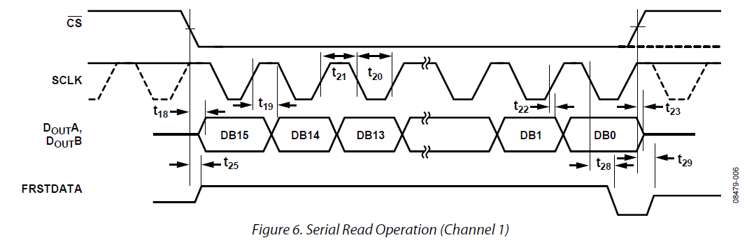

Figure 5: AD7606 Serial Read Operation (Figure 6 from [])

#### ADC Module Implementation

The ADC Module triggers ADC reads, packetizing read data, and writing packets to the USB FIFO. Figure 6 provides a block diagram of the ADC Module. Table 4 provides an overview of all IO for the module. provides an overview of the sequence of events performed by the ADC Module. Note that Table 4 groups signals into multiple headings (USB FIFO, ADC Comm, and ADC Control) and that Figure 6 uses these groupings for defining connections.

|  |  |
| --- | --- |
| **Signal Name** | **Description** |
| **USB FIFO Signals** | |
| FIFO_DIN | 8-bit parallel data bus for writing to the USB FIFO |
| FIFO_WR_EN | Pulsing signal writes data on FIFO_DIN to USB FIFO (Active High) |
| FIFO_WR_CLK | Clock driving the operation of the FIFO write side |
| FIFO_PROG_FULL | Flag indicating the FIFO has reached a programmable threshold (currently 32256). This is used to ensure that there is enough room for a full packet to be written to the FIFO before starting. |
| **ADC Communication Signals (AD7606)** | |
| CS | Chip Select. Frames data transfer (Active Low) |
| sCLK | Serial Clock for data transfers. Data clocked in on rising edge. |
| doutA | Serial data out A. Channels 1, 2, 3, and 4 are clocked in on doutA. |
| doutB | Serial data out B. Channels 5, 6, 7, and 8 are clocked in on doutB. |
| **ADC Control Signals (AD7606)** | |
| adcRANGE | Analog input range select.  0: +- 5 V  1: +- 10 V (RTSC Setting) |
| adcRESET | Reset signal (Active High). Upon initialization reset is held high for 30 ms. |
| adcSTDBY | Standby Mode (Active Low).  For RTSC, adcSTDY = 1 (unused) |
| convStA | Conversion Start A (Active Low). Pulse to initiate conversions on analog input channels. ConvStA and ConvStB are tied together in the RTSC to allow synchronized sampling. |
| convStB | Conversion Start B (Active Low). Pulse to initiate conversions on analog input channels. ConvStA and ConvStB are tied together in the RTSC to allow synchronized sampling. |
| ovrSAMPLE | Used to select the oversampling ratio. Set to 000 to disable oversampling. |
| refSEL | 0: Internal reference disabled  1: Internal reference used (RTSC Setting) |
| serSEL | 0: Parallel Interface selected  1: Serial Interface selected (RTSC Setting) |
| Busy | Indicates to the RTSC when the conversion has started (set high by the AD7606) and when it completes (set low by the AD7606). |

Table 4: Analog-to-Digital Converter Module Signals



Figure : ADC Module Block Diagram



Figure 7: ADC Module Flow Chart

The ADC Module uses a 22 us timer to send a start signal to the ADC Capture Module, which initiates a conversion and reads the resulting sampled data. The ADC Module idles until the ADC Capture Module has completed its task. The captured data is then packetized for transmission and written to the USB FIFO.

Table 5 shows the contents of the 32 byte packet. The Start Flag (0xA55A) provides an easy to identify indicator for the start of the packet. It is followed by a 32-bit time counter, which indicates a time between 0 and 85.9 seconds assuming it is incremented with a 50 MHz (20 ns) clock. This provides a relative offset for data analysis. Each channel has one byte for its channel number and 2 bytes for its 16-bit ADC reading. The last two bytes of the packet are a 16-bit checksum for message validation.

|  |  |  |
| --- | --- | --- |
| **Acquisition Packet Structure** | | |
| **Byte #** | **Field** | **Value** |
| 1-2 | Start Flag | 0xA55A |
| 3-6 | Time Offset | 32-bit time counter |
| 7 | Channel 1 Indicator | 0x01 |
| 8-9 | Channel 1 Data | 16-bit Channel 1 ADC Data |
| 10 | Channel 2 Indicator | 0x02 |
| 11-12 | Channel 2 Data | 16-bit Channel 2 ADC Data |
| 13 | Channel 3 Indicator | 0x03 |
| 14-15 | Channel 3 Data | 16-bit Channel 3 ADC Data |
| 16 | Channel 4 Indicator | 0x04 |
| 17-18 | Channel 4 Data | 16-bit Channel 4 ADC Data |
| 19 | Channel 5 Indicator | 0x05 |
| 20-21 | Channel 5 Data | 16-bit Channel 5 ADC Data |
| 22 | Channel 6 Indicator | 0x06 |
| 23-24 | Channel 6 Data | 16-bit Channel 6 ADC Data |
| 25 | Channel 7 Indicator | 0x07 |
| 26-27 | Channel 7 Data | 16-bit Channel 7 ADC Data |
| 28 | Channel 8 Indicator | 0x08 |
| 29-30 | Channel 8 Data | 16-bit Channel 8 ADC Data |
| 31-32 | Checksum |  |

Table 5: Acquisition Packet Structure

#### ADC Capture Module Implementation

The ADC Capture module drives the AD7606 signals.

Figure 8 provides a flow chart showing the functional operation of the ADC Capture module. Upon module reset and startup the ADC Capture Module holds the ADC7606 reset signal high. After 30 ms, reset is cleared and the module sits idle until it receives the ADC_Capture_Start signal from the ADC Module 22 us timer. It then pulses low convStA and convStB to command the AD7606 to start a conversion for all channels. The busy signal is then monitored to determine when the AD7606 conversion has completed. Upon completion, CS is dropped low and the data for each channel is clocked in on doutA and doutB. Channel data is placed into registers accessible to the ADC Module and the transaction complete signal is pulsed high to notify the ADC Module.



Figure 8: ADC Capture Module Flow Chart

### Digital-to-Analog Converter Module

The Digital-to-Analog Converter (DAC) Module is used to drive the AD5678 on the Electrophysiology Interface board. Amplitude-Time pair waveforms are sent from the PC to the RS232 module and are saved to DRAM on the Real Time System Controller (RTSC). Bus arbitration on both the memory interface and the 3-wire communication interface to the AD5678 allows four unique waveforms to be output by the AD5678 simultaneously.

#### AD5678

The AD5678 is a digital-to-analog converter that provides four 16-bit channels and four 12-bit channels. For the Data Acquisition and Stimulation System only the four 16-bit channels are used. Each of these channels can output between 0V to 5V. The AD5678 supports a 3-wire synchronous serial communication interface shown in . A write operation consists of the SYNC signal being driven low, 32-bits of data being clocked out, and the SYNC signal returning high. LDAC is pulled low in hardware, resulting in any update to the AD5678 output channels occurring immediately after the serial write is complete.



Figure 9: AD5678 Serial Write (Figure 2 from [])

#### DAC Module Implementation

shows the structure of the DAC Module implementation. provides a brief description of each of the DAC Module IO signals. Note that groups signals into multiple headings (Control, SPI, RAM, and RAM Arbiter) and that uses these groupings for defining connections.

|  |  |
| --- | --- |
| **Signal Name** | **Description** |
| clk | Main clock for module (50 MHz) |
| reset | Module reset (active low). All registers return to startup values. |
| **Control Signals** | |
| Stimulation | Stimulation register contents (active high). See .  Channel bit pulse active results in single stimulation waveform. Channel bit held active results in multi-stimulation. |
| Stim_Active | Flag indicating channel is currently outputting a stimulation waveform. |
| Init_Complete | Flag indicating DAC_Init module has completed AD5678 configuration and the AD5678 is ready for stimulation output. |
| **SPI Signals (AD5678)** | |
| SPI_CLK | Clock for SPI bus (5 MHz) |
| CS | Frame indicator for AD5678 SPI bus (Active Low). |
| MOSI | Output data for SPI bus to AD5678. (Master Out Slave In) |
| **RAM Signals** | |
| RAM_Start_Op | Trigger for the RAM module to start a memory operation. |
| RAM_Op_Done | Flag indicating the memory operation has completed. |
| RAM_WE | Write enable indicator for the RAM module.  0: Write Operation  1: Read Operation |
| RAM_ADDR | Memory address for the commanded operation. |
| RAM_DOUT | 16-bit output data bus from RAM used for read operations. |
| RAM_DIN | 16-bit input data bus to RAM used for write operations. |
| **RAM Arbiter Signals** | |
| RAM_Bus_Request | Request signal for accessing memory interface.  Bit 0: DAC_Channel 1 module Bus Request  Bit 1: DAC_Channel 2 module Bus Request  Bit 2: DAC_Channel 3 module Bus Request  Bit 3: DAC_Channel 4 module Bus Request |
| RAM_Bus_Busy | Flag indicating memory interface is currently in use. |
| RAM_Bus_Grant | Signal granting access to memory interface received in response to a bus request.  Bit 0: DAC_Channel 1 module Bus Grant  Bit 1: DAC_Channel 2 module Bus Grant  Bit 2: DAC_Channel 3 module Bus Grant  Bit 3: DAC_Channel 4 module Bus Grant |

Table 6: DAC Module Signals



Figure 10: Block diagram of the DAC module IO and internal modules

#### DAC Init Module Implementation

On reset the DAC_Init state machine performs initialization of the AD5678 registers. The Power-On Reset command sets all DAC channel outputs to 0V. The Internal Reference Register is then configured to turn on and use the internal voltage reference of 2.5V. The LDAC register is configured to have all channels update immediately after receiving a new output command. The Clear Code Register is configured to set the output register of each DAC to zero if CLR is driven low; however, in the prototype this signal is simply pulled down and ignored. The output register for each of the DAC channels is then set to midscale, yielding 0V on the stimulation electrode connected to the Electrophysiology Interface board [15], and the DAC_Init module waits in its IDLE state until a reset command.



Figure 11: DAC_Init Flow Chart

#### DAC Channel Module Implementation

Each of the four supported DAC channels has its own separate module. Each channel has its own section of memory for storing waveforms as time-amplitude pairs. Time values are 16-bits, with each step accounting for 1 us of delay. Amplitude values are 16-bits, providing the value to update to the DAC output register for the given channel. Time values provide the amount of time to hold the corresponding amplitude value. Each of the four channels can output waveforms simultaneously due to bus arbitration logic for memory and SPI communication.

The DAC_Channel module supports single stimulation (sending the stored waveform once) and multi-stimulation (sending the stored waveform repeatedly). For single stimulation the “Stimulation” signal is set for a single clock cycle and for multi-stimulation the “Stimulation” signal is set and held high for as long as the repeating output is desired.

Upon setting the corresponding Stimulation Register bit (see Stimulation Register section of this document) of a DAC_Channel module, the number of samples stored in memory for the channel is read. From here, the first time-amplitude pair is read, SPI bus access requested, and the DAC output is updated. After waiting for the number of 1 us counts specified by the time value, the process is repeated for each time-amplitude pair. Upon reaching the last time-amplitude pair for a single stimulation, the DAC_Channel module returns to IDLE and waits for the next time “Stimulation” is set. During a multi-stimulation, the module returns to the first sample and loops through the entire set until “Stimulation” is no longer set.



Figure 12: DAC_Channel Flow Chart

Table 7 provides the memory locations where waveforms are stored for each channel. Each channel is provided 0x1000 (4096) 8-bit memory locations. NumSamples is stored in the first location for each channel and from there samples are stored, each one taking 32-bits. This means each channel has a maximum number of samples per waveform of 1023 (4096 - 8-bit locations / 32-bit samples – 8-bit NumSamples value).

|  |  |  |
| --- | --- | --- |
| Memory Location  (23-bit addresses,  top 7 bits ignored) | Channel # | Content |
| 0x0000 | Channel 1 | NumSamples |
| 0x0001-0x0002 | Channel 1 | Sample 1 – Amplitude |
| 0x0003-0x0004 | Channel 1 | Sample 1 - Time |
| … | … | … |
| 0x1000 | Channel 2 | NumSamples |
| 0x1001-0x1002 | Channel 2 | Sample 1 – Amplitude |
| 0x1003-0x1004 | Channel 2 | Sample 1 - Time |
| … | … | … |
| 0x2000 | Channel 3 | NumSamples |
| 0x2001-0x2002 | Channel 3 | Sample 1 – Amplitude |
| 0x2003-0x2004 | Channel 3 | Sample 1 - Time |
| … | … | … |
| 0x3000 | Channel 4 | NumSamples |
| 0x3001-0x3002 | Channel 4 | Sample 1 – Amplitude |
| 0x3003-0x3004 | Channel 4 | Sample 1 - Time |
| … | … | … |

Table 7: Memory Locations for Stimulation Waveforms

#### DAC SPI Module Implementation

The Real Time System Controller (RTSC) acts as the SPI master device and the AD5678 acts as the slave, meaning the RTSC drives “sclk”, “sync”, and “din”. The SPI Module is configured for 5MHz and only supports transmit (the AD5678 does not send information back to RTSC). The data to send is provided to the module and SPI_Start is pulsed high, beginning the transmission. Sync is driven low indicating the beginning of the transmission to the AD5678. The 32 data bits are then clocked out and the module returns to IDLE.



Figure 13: SPI Transmit Flow Chart

### RS232 Module

The RS232 Module provides the communication interface to the PC application for command and control of the RTSC. Supported commands are described in the RTSC Application Programming Interface (API) section of this document. Received commands are placed in the RX FIFO, where they are processed by the Command Handler Module and an appropriate reply is placed in the TX FIFO and transmitted.

RS232 is an asynchronous, full-duplex protocol. The rate of transmission is known as the baud rate. For RTSC, 115200 baud is used, meaning each bit is 8.68 us wide. RTSC also uses standard 8 data bits, 1 stop bit, and no parity bit (N81). Figure 14 shows a standard N81 RS232 transaction (TTL logic levels). The data is high when idle, dropping low to indicate start of transmission. The 8 data bits are then transmitted least significant bit first. The transmission ends with the stop bit pulling the data line high.



Figure 14: RS232 8-bit Transaction

#### RS232 Module Implementation

shows the structure of the RS232 Module implementation. provides a brief description of each of the RS232 Module IO signals. Note that groups signals into multiple headings (RS232, TX FIFO Write, RX FIFO Read, and Debug) and that uses these groupings for defining connections.



Figure : RS232 Block Diagram

|  |  |
| --- | --- |
| **Signal Name** | **Description** |
| clk | Main clock for module (50 MHz) |
| reset | Module reset (active low). All registers return to startup values. |
| **RS232 Signals** | |
| TX | Asynchronous Serial Transmit (115200 baud) |
| RX | Asynchronous Serial Receive (115200 baud) |
| **TX FIFO Write Signals** | |
| TX_FIFO_WR_CLK | TX FIFO write clock. |
| TX_FIFO_DIN | 8-bit data input to the TX FIFO. |
| TX_FIFO_WR_EN | TX FIFO Write Enable (Active High). |
| **RX FIFO Read Signals** | |
| RX_FIFO_RD_CLK | RX FIFO read clock. |
| RX_FIFO_DOUT | 8-bit data output from the RX FIFO. |
| RX_FIFO_RD_EN | RX FIFO Read Enable (Active High). |
| RX_FIFO_EMPTY | Flag indicating the RX FIFO is empty. |
| **Debug Signals** | |
| TX_led | Flag indicating the TX module is active. Routed to LED on the RTSC for visual feedback. |
| RX_led | Flag indicating the RX module is active. Routed to LED on the RTSC for visual feedback. |

Table 8: RS232 Module Signals

#### TX Module

The TX Module reads data from the TX FIFO and transmits it over the serial asynchronous TX RS232 line. provides a flow chart of the module.

The module waits in an idle state until the TX FIFO is not empty, indicating there is data ready for transmission. The TX Module then transmits data as shown in Figure 14, dropping the TX line low to indicate the start bit, transmitting the 8 data bits, and then pulling the TX line high again to indicate end of transmission. The module then performs an inter-byte wait period of 200 ns, meaning it will not attempt to transmit another byte until the inter-byte period has elapsed. The TX FIFO read enable signal is then pulsed high to remove the transmitted data from the FIFO and the module returns to idle, awaiting additional data to be placed into the TX FIFO.



Figure 16: TX Module Flow Chart

#### RX Module

provides a flow chart of the RX Module. The module is idle until the falling edge of the RX line, signaling the start bit. The module then waits for 1.5 times the baud delay and reads the middle of the first data bit. Subsequent data bits are read in, with only the baud delay between to remain in the middle of the bit. Upon reading the 8th bit, the module waits for the stop bit to indicate the end of the transmission and writes the byte to the RX FIFO.



Figure : RX Module Flow Chart

### RAM Module

The RAM module drives the interface to the Micron MT45W8MW16BGX RAM chip that is on the RTSC board. The RAM is used for storing stimulation waveforms. To allow different modules to make use of the RAM an arbitration module has also been implemented.

#### Micron MT45W8MW16BGX

The Micron MT45W8MW16BGX is a CMOS pseudo-static random access memory that provides 128 Mb of DRAM. For this application, single asynchronous reads and writes are used.

Figure 18 provides a timing diagram showing an asynchronous read operation. Note that write enable (WE#) is held high, indicating a read operation. The address must be valid when CE, OE, LB, and UB are pulled low and valid data is placed on the Data bus after 85 ns.



Figure : MT45W8MW16BGX Asynchronous Read Operation (Figure 5 from [])

Figure 19 provides a timing diagram showing an asynchronous write operation. Note that write enable (WE#) is low, indicating a write operation. The address must be valid when CE, OE, LB, and UB are pulled low and valid data must be ready on the Data bus within 85 ns.



Figure : MT45W8MW16BGX Asynchronous Write Operation (Figure 6 from [])

#### RAM Module Implementation

Figure 20 shows the structure of the RAM Module implementation. Table 9 provides a brief description of each of the RAM Module IO signals. Note that Table 9 groups signals into multiple headings (MT45W8MW16BGX, RAM Module Control, and RAM Arbiter) and that Figure 20 uses these groupings for defining connections.



Figure : RAM Module Block Diagram

|  |  |
| --- | --- |
| **Signal Name** | **Description** |
| clk | Main clock for module (50 MHz) |
| reset | Module reset (active low). All registers return to startup values. |
| **MT45W8MW16BGX Signals** | |
| MT_ADDR | RAM Address. |
| MT_DATA | 16-bit bi-directional RAM data bus. |
| MT_OE | RAM Output enable (active low). |
| MT_WE | 0: Write Operation  1: Read Operation |
| MT_ADV | Address valid (active low). Indicates the current value on MT_ADDR is valid. |
| MT_CLK | Clock. RTSC uses asynchronous operation and holds the clock low. |
| MT_UB | Upper Byte enable |
| MT_LB | Lower Byte enable |
| MT_CE | Chip Enable (active low). |
| MT_CRE | Control Register Enable. Held low for RTSC, feature unused. |
| **RAM Module Control** | |
| RAM_Start_Op | Trigger for the RAM module to start a memory operation. |
| RAM_Op_Done | Flag indicating the memory operation has completed. |
| RAM_WE | Write enable indicator for the RAM module.  0: Write Operation  1: Read Operation |
| RAM_ADDR | Memory address for the commanded operation. |
| RAM_DOUT | 16-bit output data bus from RAM used for read operations. |
| RAM_DIN | 16-bit input data bus to RAM used for write operations. |
| **RAM Arbiter Signals** | |
| RAM_Bus_Request | Request signal for accessing memory interface. |
| RAM_Bus_Busy | Flag indicating memory interface is currently in use. |
| RAM_Bus_Grant | Signal granting access to memory interface received in response to a bus request. |

Table 9: RAM Module Signals

Figure 21 provides a flow chart of the RAM Module. Upon startup the module idles for 150 us allowing the MT45W8MW16BGX to initialize. The module then idles until a RAM start operation request is received. Based on RAM_WE, a single asynchronous read (RAM_WE = 1) or asynchronous write (RAM_WE = 0) is performed. The module then pulses RAM_Op_Done high to indicate the operation is complete and returns to the idle state.



Figure : RAM Module Flow Chart

### USB Module

The USB Module pulls packetized data from the USB FIFO and passes it on to the Cypress EZ-USB over the synchronous slave FIFO bus. Figure 22 provides a block diagram showing a synchronous slave FIFO transaction. For this interface the Cypress EZ-USB serves as the master and the FPGA serves as the slave. To start a transaction, the FPGA pulls the SLWR line low, indicating a slave write request. On each following rising edge of the slave FIFO clock the Cypress EZ-USB captures data into its internal FIFOs in preparation for USB transmission.



Figure : Synchronous Slave FIFO (as described in [23])

#### USB Module Implementation

Figure 23 shows the structure of the USB Module implementation. Table 10 provides a brief description of each of the USB Module IO signals. Note that Table 10 groups signals into multiple headings (Synchronous Slave FIFO, USB FIFO, and Debug Outputs) and that Figure 23 uses these groupings for defining connections.



Figure : USB Module Block Diagram

|  |  |
| --- | --- |
| **Signal Name** | **Description** |
| clk | Slave FIFO clock. Sourced from the Cypress EZ-USB. |
| reset | Module reset (active low). All registers return to startup values. |
| FIFOADDR_in | Input routed to switches on Nexys2 dev board. Address of Cypress EZ-USB endpoint FIFO to write to. Current configuration should keep this set to “00”. |
| **Synchronous Slave FIFO Signals** | |
| Data | 8-bit data bus |
| PktEnd | End of packet indicator (active low). Trigger Cypress EZ-USB to send a USB packet, even if the corresponding FIFO is not full. Unused for RTSC. |
| FlagB | Flag indicating the Cypress FIFOs are full (active low). |
| SLRD | Data is read from the Cypress EZ-USB FIFO upon assertion of SLRD (active read). Unused for RTSC. |
| SLWR | Data is written to the Cypress EZ-USB FIFO upon assertion of SLWR (active low). |
| SLOE | Enables the Cypress EZ-USB to drive data on the Data bus (active low). Used in conjunction with SLRD. Unused in RTSC. |
| FIFOADDR | Address of Cypress EZ-USB endpoint FIFO to write to. |
| **USB_FIFO Signals** | |
| FIFO_DOUT | 8-bit parallel data bus |
| FIFO_RD_CLK | USB_FIFO read clock |
| FIFO_RD_EN | USB FIFO Read Enable (Active High). |
| FIFO_EMPTY | Flag indicating the USB FIFO is empty (Active High). |
| FIFO_ALMOST_EMPTY | Flag indicating one word from empty (Active High). |
| FIFO_PROG_EMPTY | Flag indicating less than or equal to 15 words in FIFO (Active High). |
| **Debug Outputs** | |
| FlagB_out | Display FlagB value to LED |
| Idle_out | Display module status to LED. When idle the USB_FIFO does not contain data to pass on to Cypress EZ-USB.  On: Module is idle  Off: Module is active |

Table 10: USB Module Signals

Figure 24 provides a flow chart of the USB Module. The module is idle until the USB FIFO “FIFO_PROG_EMPTY” flag is de-asserted, indicating a full packet is available. The module then reads the first byte from the USB FIFO and writes it to the Cypress EZ-USB Synchronous Slave FIFO. This is repeated for all 16 bytes of the packet and then the module returns to idle.



Figure : USB Module Flow Chart

### Command Handler Module

RTSC API commands (see RTSC Application Programming Interface (API) section of this document) are received over RS232 and placed in the RX FIFO. The Command Handler process and acts on these commands and places the RS232 reply into the TX FIFO from where it will be transmitted back to the PC application.

#### Command Handler Implementation

Figure 25 shows the structure of the Command Handler implementation. Table 11 provides a brief description of the Command Handler IO signals. Note that Table 11 groups signals into multiple headings (RTSC Register Configuration, RX FIFO, TX FIFO, RAM Module, and RAM Arbiter) and that Figure 25 uses these groupings for defining connections.

Figure : Command Handler Module Block Diagram

|  |  |
| --- | --- |
| **Signal Name** | **Description** |
| clk | Slave FIFO clock. Sourced from the Cypress EZ-USB. |
| reset | Module reset (active low). All registers return to startup values. |
| **RTSC Register Configuration** | |
| Channel 1-8 Configuration | Channel Configuration Registers (see Table 1) |
| Stimulation | Stimulation Register (see Table 2) |
| Acquisition | Stimulation Register (see Table 3) |
| **RX_FIFO Signals** | |
| RX_FIFO_RD_CLK | RX FIFO read clock |
| RX_FIFO_DOUT | 8-bit data bus for reading from RX FIFO |
| RX_FIFO_RD_EN | RX FIFO Read Enable (Active High). |
| RX_FIFO_EMPTY | Flag indicating the RX FIFO is empty (Active High). |
| **TX_FIFO Signals** | |
| TX_FIFO_WR_CLK | TX FIFO write clock |
| TX_FIFO_DIN | 8-bit data bus for writing to TX FIFO |
| TX_FIFO_WR_EN | TX FIFO Write Enable (Active High). |
| **RAM_Module Control** | |
| RAM_Start_Op | Trigger for the RAM module to start a memory operation. |
| RAM_Op_Done | Flag indicating the memory operation has completed. |
| RAM_WE | Write enable indicator for the RAM module.  0: Write Operation  1: Read Operation |
| RAM_ADDR | Memory address for the commanded operation. |
| RAM_DOUT | 16-bit output data bus from RAM used for read operations. |
| RAM_DIN | 16-bit input data bus to RAM used for write operations. |
| **RAM_Arbiter Signals** | |
| RAM_Bus_Request | Request signal for accessing memory interface. |
| RAM_Bus_Busy | Flag indicating memory interface is currently in use. |
| RAM_Bus_Grant | Signal granting access to memory interface received in response to a bus request. |

Table 11: Command Handler Module Signals

Figure 26 provides a flow chart of the Command Handler module. The module is idle until the RX_FIFO_EMPTY flag indicates that data is available in the RX FIFO. Upon reception of a start byte (0x5A), indicating the start of an API message, the module reads in and processes the message header. The header contains the Message ID, Message Length, and channel the message is intended for. From there, the appropriate message specific handler is started to perform the commanded action. See the RTSC Application Programming Interface (API) section of this document for more information regarding the supported API commands and actions performed upon reception of each command.



Figure : Command Handler Flow Chart

## RTSC Cypress EZ-USB

The Cypress CY7C68013A [23] is provided on the Nexys2 development board. It is used for programming the FPGA via USB and supports user data transfers.

### FPGA Programming

The Cypress CY7C68013A is connected to the Joint Test Action Group (JTAG) bus and can be used to load the configuration file for the FPGA. The Cypress CY7C68013A receives the configuration file and command to program the FPGA through USB and drives the JTAG bus to complete the command. The **Error! Reference source not found.** appendix provides a detailed overview of how to load the configuration file. The Xilinx Platform Flash configuration PROM and Xilinx XC9572XL CPLD are also on the JTAG scan chain and may be programmed by the Cypress CY7C68013A[15, 19].

### USB Data Transfers

The original Digilent® firmware that is loaded from EEPROM on startup supports Bulk USB transfers of size 512 bytes and a 1024 byte FIFO. In order to provide minimal latency and guaranteed reception for acquired ADC data, custom firmware was required. The custom firmware configures the Cypress CY7C68013A for Interrupt transfers of size 1024 over a single endpoint with a 4096 byte FIFO. Digilent® does not support modification of the firmware and it is claimed that doing so will void the board. However, it is possible to write alternative firmware to the volatile internal memory of the chip, providing a solution where you are able reprogram the firmware, but the original Digilent® firmware remains in the EEPROM and is loaded whenever power to the board is cycled.

|  |  |  |  |  |  |
| --- | --- | --- | --- | --- | --- |
|  | VID:PID | USB Transfer Mode | Endpoints Supported | Packet Size | FIFO Size (per endpoint) |
| Digilent Firmware | 1443:0005 | Bulk | 2,4,6,8 | 512 | 1024 |
| Custom Firmware | 04B4:8613 | Interrupt | 2 | 1024 | 4096 |

Table 12: Digilent Firmware Vs. Custom Firmware USB Configuration

Table 12 provides an overview of the USB configuration for Digilent’s firmware and the custom firmware. As noted above, the custom firmware supports Interrupt USB transfers. Interrupt transfers are necessary because they have a guaranteed latency, meaning every 125 us microframe the OS will service the USB endpoint. Interrupt transfers also allow for error detection and retry to guarantee valid data reception.

## Data Acquisition and Stimulation Control Center

The developed PC application issues commands (via RS232) to the Real Time System Controller (RTSC) board and receives acquired data (via USB) from the RTSC board. Commands can be sent manually from the GUI or automated through scripting. Acquired data can be graphed, including support for overlaying multiple channels on the same plot and the option to export to a comma separated values (.csv) file for analysis using other applications (ex. Matlab®, Excel®). Figure 27 provides a screenshot of the PC Application with a script loaded and two channels of acquired data overlaid on the same plot.

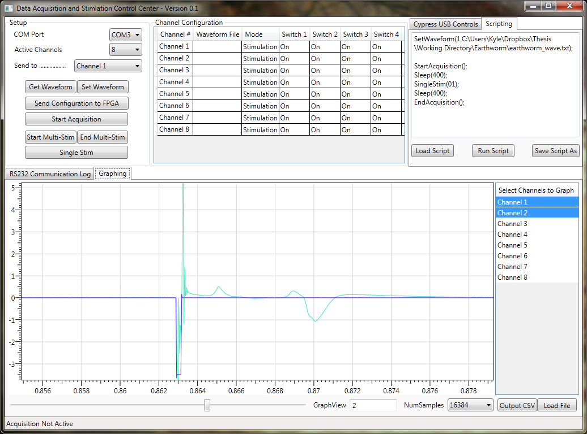

Figure : Data Acquisition and Stimulation Control Center

### PC Application Design

Figure 28 provides the class diagram for the Data Acquisition and Stimulation Control Center. Each of the primary functional classes is displayed, ignoring the main window class and a few other supporting classes.

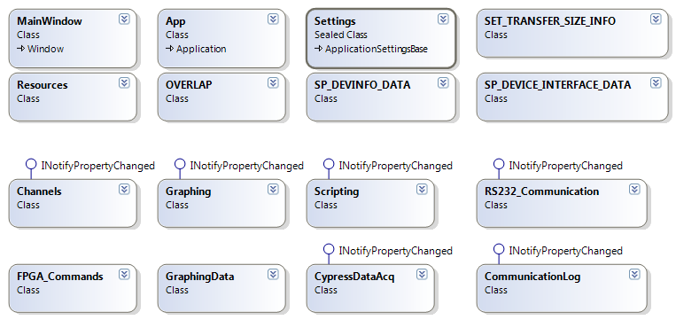

Figure 28: DASCC class diagram

#### Channels Class

The Channels class serves as a container for channel configuration data. The current version of DASCC supports from 1 to 8 active channels, each of which can be configured for Stimulation or Acquisition.

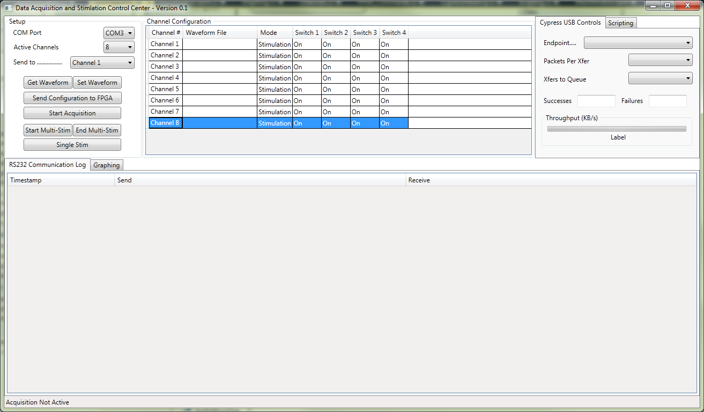

Figure : DASCC Channel Configuration

Figure 29 shows the portion of the GUI that is bound directly to each active Channels class object. By changing “Active Channels” the number of Channels class objects are displayed and each can be configured within the data grid view. Double Clicking the “Waveform File” column launches an “Open File” dialog box allowing the user to point directly to the desired waveform file. The Switch 1-4 settings provided allow for future control of the pre-amp switches; RTSC does not yet support direct control of these switches.

#### Graphing Class

The Graphing Class provides graphing functionality and control over the set of data that is currently displayed. It leverages the Dynamic Data Display [27] graphing library. Support has ceased for the library but the base functionality it provides suited this application and it is available under Microsoft Reciprocal License (Ms-RL), a Microsoft open-source license. Figure 30 shows the Graphing view and related controls.



Figure : DASCC Graphing View

After data is acquired it can be loaded into the Graphing view by selecting the “Graphing” tab and hitting the “Load File” button. Based on the number of channels contained within the loaded data the “Select Channels to Graph” list box will be populated and the first channel will be selected. Data from multiple channels can be overlaid using Ctrl+LeftMouse to select and deselect channels. Due to the large number of samples each data file can hold, the view is divided into a configurable number of samples selected using the “NumSamples” control. Upon dividing data, the slider bar is used to move through each NumSamples set of data. The current set index is shown in the “GraphView” textbox.

#### GraphingData Class

The GraphingData class serves as a container for the data loaded from file and the data that is displayed in the Graphing view. For more details on graphing functionality see the Graphing Class.

#### Scripting Class

The Scripting class interprets user scripts and triggers the appropriate actions sequentially. The **Error! Reference source not found.** appendix provides an overview of the supported scripting commands.



Figure : DASCC Scripting View

Figure 31 shows the scripting view with a loaded script. “Load Script” allows the user to select a script file to load. “Save Script As” with save the currently loaded script to file. “Run Script” sequentially performs the script commands currently loaded.

#### RS232 Communication Class

The RS232 Communication class provides the functionality of opening a port, closing a port, sending data, and receiving data. The FPGA_Commands class contains a RS322 Communication class object for performing serial communication. Manual and scripted commands using the RTSC Application Programming Interface (API) are transmitted to the RTSC using the RS232 Communication Class.

#### FPGA_Commands Class

The FPGA Commands class builds RTSC Application Programming Interface (API) requests provided the command to send and the appropriate parameters. It contains a RS322 Communication class object for performing serial communication.

#### CypressDataAcq Class

The CypressDataAcq Class handles data acquisition from the Cypress CY7C68013A using the CyUSB C# Class Library. The CypressDataAcq code is a modified version of “Streamer”, which is a demo application installed with Cypress Suite USB. Additions to the existing code include clearing of the data buffers and writing captured data to file. Modification of the internal data buffer size of the CyUSB C# Class Library is also performed, upping the buffer to 0x800000 (8388608) Bytes, or 128 65536 byte packets.

#### CommunicationLog Class

The CommunicationLog class serves as a container for all sent and received communication over the RS232 interfaces, including the related timestamp. A list is maintained of CommunicationLog objects and bound to the, “RS232 Communication Log” tab of the DASCC.

### RTSC Application Programming Interface (API)

The Real Time System Controller (RTSC) board accepts commands over RS232 for controlling its operation. Collectively, these commands make up the RTSC API. The PC Application implements the RTSC API.

Each message has a common header that contains the StartByte (0x5A), the MessageID, and the 16-bit length of the message.

#### Set Channel Configuration

The Set Channel Configuration request allows the 8-bit Channel Configuration register (see Table 1) for each channel to be modified. The Channel field specifies the channel register to modify, with channel 1 being 0x01, on up to channel 8 being 0x08. The Configuration byte is the desired value for the Channel Configuration register.

|  |  |  |
| --- | --- | --- |
| Set Channel Configuration Request (0x01) | | |
| Byte # | **Field** | **Value** |
| 1 | StartByte | 0x5A |
| 2 | Message ID | 0x01 |
| 3-4 | Length | 0x0007 |
| 5 | Channel |  |
| 6 | Configuration |  |
| 7 | Checksum |  |

Table : Set Channel Configuration Request

The Set Channel Configuration reply returns the channel of the register that was modified and its updated value. This should be checked against the requested channel and configuration to verify the register has been updated successfully.

|  |  |  |
| --- | --- | --- |
| Set Channel Configuration Reply (0x81) | | |
| Byte # | **Field** | **Value** |
| 1 | StartByte | 0x5A |
| 2 | Message ID | 0x81 |
| 3-4 | Length | 0x0007 |
| 5 | Channel | same as request |
| 6 | Configuration | same as request |
| 7 | Checksum |  |

Table : Set Channel Configuration Reply

#### Get Channel Configuration

The Get Channel Configuration request queries the RTSC for the current value of the specified channel’s Configuration Register.

|  |  |  |
| --- | --- | --- |
| Get Channel Configuration Request (0x02) | | |
| Byte # | **Field** | **Value** |
| 1 | StartByte | 0x5A |
| 2 | Message ID | 0x02 |
| 3-4 | Length | 0x0006 |
| 5 | Channel |  |
| 6 | Checksum |  |

Table : Get Channel Configuration Request

The Get Channel Configuration reply returns the current value of the requested channel’s Configuration Register.

|  |  |  |
| --- | --- | --- |
| Get Channel Configuration Reply (0x82) | | |
| Byte # | **Field** | **Value** |
| 1 | StartByte | 0x5A |
| 2 | Message ID | 0x82 |
| 3-4 | Length | 0x0007 |
| 5 | Channel | same as request |
| 6 | Configuration |  |
| 7 | Checksum |  |

Table : Get Channel Configuration Reply

#### Set Acquisition Register

The Set Acquisition Register request provides the RTSC with a new value for the Acquisition Register. See Table 3 for guidance in the appropriate value for the register.

|  |  |  |
| --- | --- | --- |
| Set Acquisition Register Request (0x03) | | |
| Byte # | **Field** | **Value** |
| 1 | StartByte | 0x5A |
| 2 | Message ID | 0x03 |
| 3-4 | Length | 0x0006 |
| 5 | Acquisition Register |  |
| 6 | Checksum |  |

Table : Set Acquisition Register Request

The Set Acquisition Register reply returns the update value of the Acquisition Register. This should be checked against the requested value to verify the register has been updated successfully.

|  |  |  |
| --- | --- | --- |
| Set Acquisition Register Reply (0x83) | | |
| Byte # | **Field** | **Value** |
| 1 | StartByte | 0x5A |
| 2 | Message ID | 0x83 |
| 3-4 | Length | 0x0006 |
| 5 | Acquisition Register | same as request |
| 6 | Checksum |  |

Table : Set Acquisition Register Reply

#### Get Acquisition Register

The Get Acquisition Register request queries the RTSC for the current value of the Acquisition Register.

|  |  |  |
| --- | --- | --- |
| Get Acquisition Register Request (0x04) | | |
| Byte # | **Field** | **Value** |
| 1 | StartByte | 0x5A |
| 2 | Message ID | 0x04 |
| 3-4 | Length | 0x0005 |
| 5 | Checksum |  |

Table : Get Acquisition Register Request

The Get Acquisition Register reply returns the current value of the Acquisition Register.

|  |  |  |
| --- | --- | --- |
| Get Acquisition Register Reply (0x84) | | |
| Byte # | **Field** | **Value** |
| 1 | StartByte | 0x5A |
| 2 | Message ID | 0x84 |
| 3-4 | Length | 0x0006 |
| 5 | Acquisition Register | same as request |
| 6 | Checksum |  |

Table : Get Acquisition Register Reply

#### Set Waveform

The Set Waveform request updates the stored stimulation waveform for the requested channel. Number of Samples provides the number of Amplitude:Time pairs for the waveform. Amplitude:Time pairs are sent sequentially, from sample 1 to sample n, followed by the message checksum. The waveform is stored to the requested channel’s memory offset as described in Table 7.

|  |  |  |
| --- | --- | --- |
| Set Waveform Request (0x05) | | |
| Byte # | **Field** | **Value** |
| 1 | StartByte | 0x5A |
| 2 | Message ID | 0x05 |
| 3-4 | Length | 6 + samples * 4 |
| 5 | Channel |  |
| 6 | Number of Samples |  |
| 7-8 | Amplitude 1 |  |
| 9-10 | Time 1 |  |
|  | Amplitude n |  |
|  | Time n |  |
| 6 + samples * 4 | Checksum |  |

Table : Set Waveform Request

The Set Waveform reply returns a status for the Set Waveform request.

|  |  |  |
| --- | --- | --- |
| Set Waveform Reply (0x85) | | |
| Byte # | **Field** | **Value** |
| 1 | StartByte | 0x5A |
| 2 | Message ID | 0x85 |
| 3-4 | Length | 0x0007 |
| 5 | Channel |  |
| 6 | Status | 0x00: Success  0x01: Failure |
| 7 | Checksum |  |

Table : Set Waveform Reply

#### Get Waveform

The Get Waveform request queries the RTSC for the currently stored stimulation waveform of the specified channel.

|  |  |  |
| --- | --- | --- |
| Get Waveform Request (0x06) | | |
| Byte # | **Field** | **Value** |
| 1 | StartByte | 0x5A |
| 2 | Message ID | 0x06 |
| 3-4 | Length | 0x0006 |
| 5 | Channel |  |
| 6 | Checksum |  |

Table : Get Waveform Request

The Get Waveform reply returns the requested channel’s stored stimulation waveform. The Number of Samples is followed by each of the Amplitude:Time pairs of the waveform.

|  |  |  |
| --- | --- | --- |
| Get Waveform Reply (0x86) | | |
| Byte # | **Field** | **Value** |
| 1 | StartByte | 0x5A |
| 2 | Message ID | 0x86 |
| 3-4 | Length | 7 + samples * 4 |
| 5 | Channel |  |
| 6 | Status | 0x00: Success  0x01: Failure |
| 7 | Number of Samples |  |
| 8-9 | Amplitude 1 |  |
| 10-11 | Time 1 |  |
|  | Amplitude n |  |
|  | Time n |  |
| 7 + samples * 4 | Checksum |  |

Table : Get Waveform Reply

#### Set Stimulation Register

The Set Stimulation Register request provides the RTSC with a new value for the Stimulation Register. See Table 2 for guidance in the appropriate value for the register. The Continuous Register allows for the support of single or multi-stimulation. One clock cycle after setting the Stimulation Register the values of the Continuous Register overwrite the Stimulation Register. This allows the Stimulation register to be pulsed high for single stimulation or held high for multi-stimulation.

As an example, assume the Stimulation Register is set to 0x03 and Continuous Register is set to 0x01. This means channels 1 and 2 are initially set, due to the 0x03 setting bits 0 and 1. After one clock cycle the contents of the Continuous Register are copied to the Stimulation Register. This means only channel 1 remains set, due to the 0x01 leaving bit 0 set and clearing bit 1. The overall result is channel 1 has been configured for multi-stimulation and channel 2 has been configured for single stimulation.

|  |  |  |
| --- | --- | --- |
| Set Stimulation Register Request (0x07) | | |
| Byte # | **Field** | **Value** |
| 1 | StartByte | 0x5A |
| 2 | Message ID | 0x07 |
| 3-4 | Length | 0x0006 |
| 5 | Stimulation Register |  |
| 6 | Continuous Register |  |
| 7 | Checksum |  |

Table : Set Stimulation Register Request

The Set Stimulation Register reply returns the current value of the Stimulation Register. Only channels configured for multi-stimulation should be set, meaning this should match the Continuous Register value from the request.

|  |  |  |
| --- | --- | --- |
| Set Stimulation Register Reply (0x87) | | |
| Byte # | **Field** | **Value** |
| 1 | StartByte | 0x5A |
| 2 | Message ID | 0x87 |
| 3-4 | Length | 0x0006 |
| 5 | Stimulation Register |  |
| 6 | Checksum |  |

Table : Set Stimulation Register Reply

#### Get Stimulation Register

The Get Stimulation Register request queries the RTSC for the current value of the Stimulation Register.

|  |  |  |
| --- | --- | --- |
| Get Stimulation Register Request (0x08) | | |
| Byte # | **Field** | **Value** |
| 1 | StartByte | 0x5A |
| 2 | Message ID | 0x08 |
| 3-4 | Length | 0x0005 |
| 5 | Checksum |  |

Table : Get Stimulation Register Request

The Get Stimulation Register reply returns the current value of the Stimulation Register.

|  |  |  |
| --- | --- | --- |
| Set Stimulation Register Reply (0x88) | | |
| Byte # | **Field** | **Value** |
| 1 | StartByte | 0x5A |
| 2 | Message ID | 0x88 |
| 3-4 | Length | 0x0006 |
| 5 | Stimulation Register |  |
| 6 | Checksum |  |

Table : Get Stimulation Register Reply

# Electrophysiology Application[4]

To validate the stimulation and data acquisition system design, a standard electrophysiology experiment, described in [12, 13], was performed on earthworm giant axon action potentials, henceforth referred to as the Earthworm Experiment. This serves the purpose of showing that the Data Acquisition and Stimulation System is capable of being used in an electrophysiology experiment, and the procedure has been performed with previous designs, allowing the new design to be compared with previous results [9].

In the earthworm's nerve cord, there is a median giant axon and two smaller lateral giant axons on either side of the median axon. The lateral giants are connected to each other at multiple locations along the length of the earthworm which has the effect of lateral axons acting as a single giant axon [12]. A physical or electrical stimulation near the anterior or posterior ends of the earthworm will elicit a response from the earthworm in the form of an action potential that propagates along one or both of the giant axons. The propagation speed is related to the cross sectional area of the axon [13]. Varying the intensity of the electrical stimulation at the anterior end of the earthworm will show no response at low intensity, an action potential along the median axon soon after the stimulation at medium intensity, and at higher intensity, action potentials along both the median and lateral giant axons will be visible with the median response occurring sooner than the lateral response due to the differing propagation speeds. Figure 32 shows a cross section of an earthworm based on a figure in [18] with a more detailed representation of the nerve cord based on [13].

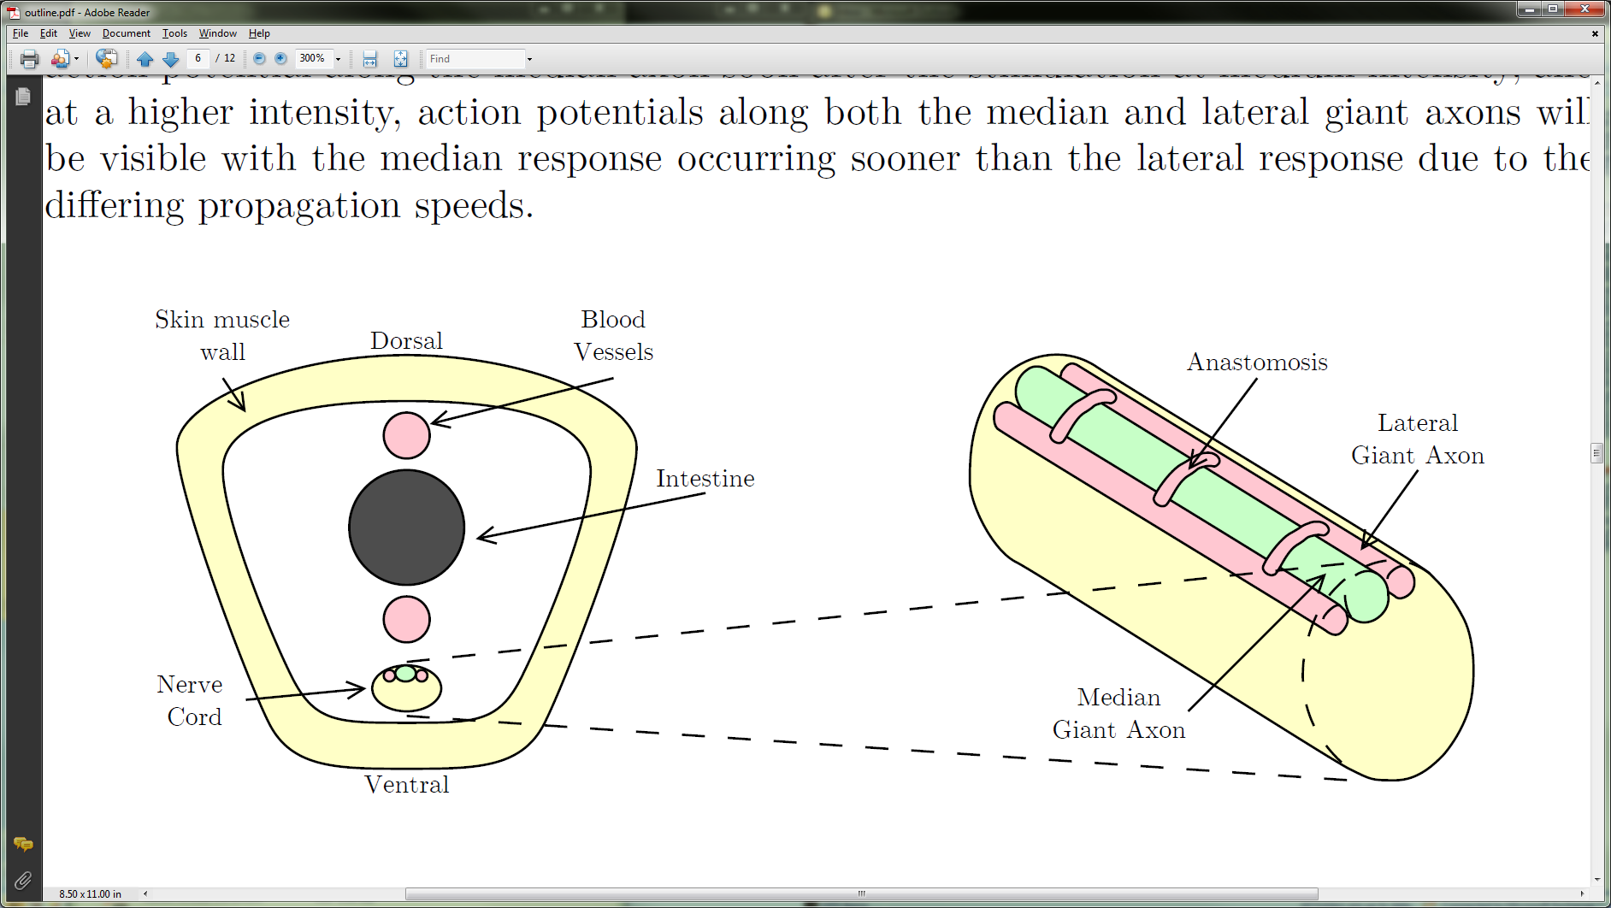

Figure 32: Cross section of an earthworm adapted from [13, 18]. Illustration by D. Squires [15].

Electrical stimulation is accomplished by placing two pins near the anterior end of the earthworm. Measurement of the action potentials along the axon is accomplished by dissecting the earthworm and placing two chlorided silver extracellular electrodes on the earthworm nerve cord. The extracellular electrodes measure the difference in electric potential at two points on the nerve cord. When an action potential propagates along the nerve cord, the electrodes measure a difference in voltage in time that will appear as a biphasic spike. The exact shape of the spike will depend on the placement and size of the electrodes and the condition of the nerve cord itself [12, 13, 24].

The Data Acquisition and Stimulation System was used to perform an experiment studying earthworm giant axon potentials with a previously developed and validated amplifier [9] and oscilloscope connected in parallel with the electrophysiology interface board, allowing the data to be compared.

## Earthworm Setup

The dissection of the earthworm and setup of the stimulation and recording hardware is based on [9, 12, 13, 14]. Two pins are placed near the anterior end of the earthworm. Connected to these pins is the output of the stimulation circuitry. Near the middle of the earthworm, the skin is cut and folded to expose the interior of the worm. The intestine is moved out of the way, and the nerve cord is pulled away from the fluids with two chlorided silver electrodes that are connected to the amplification and recording circuitry. Between the stimulation pins and recording electrodes, a chlorided silver wire is placed under the body of the earthworm and connected to circuit ground, which may be connected to earth ground depending on the circuit setup. Figure 33 is a diagram of the DASS connected to the earthworm.

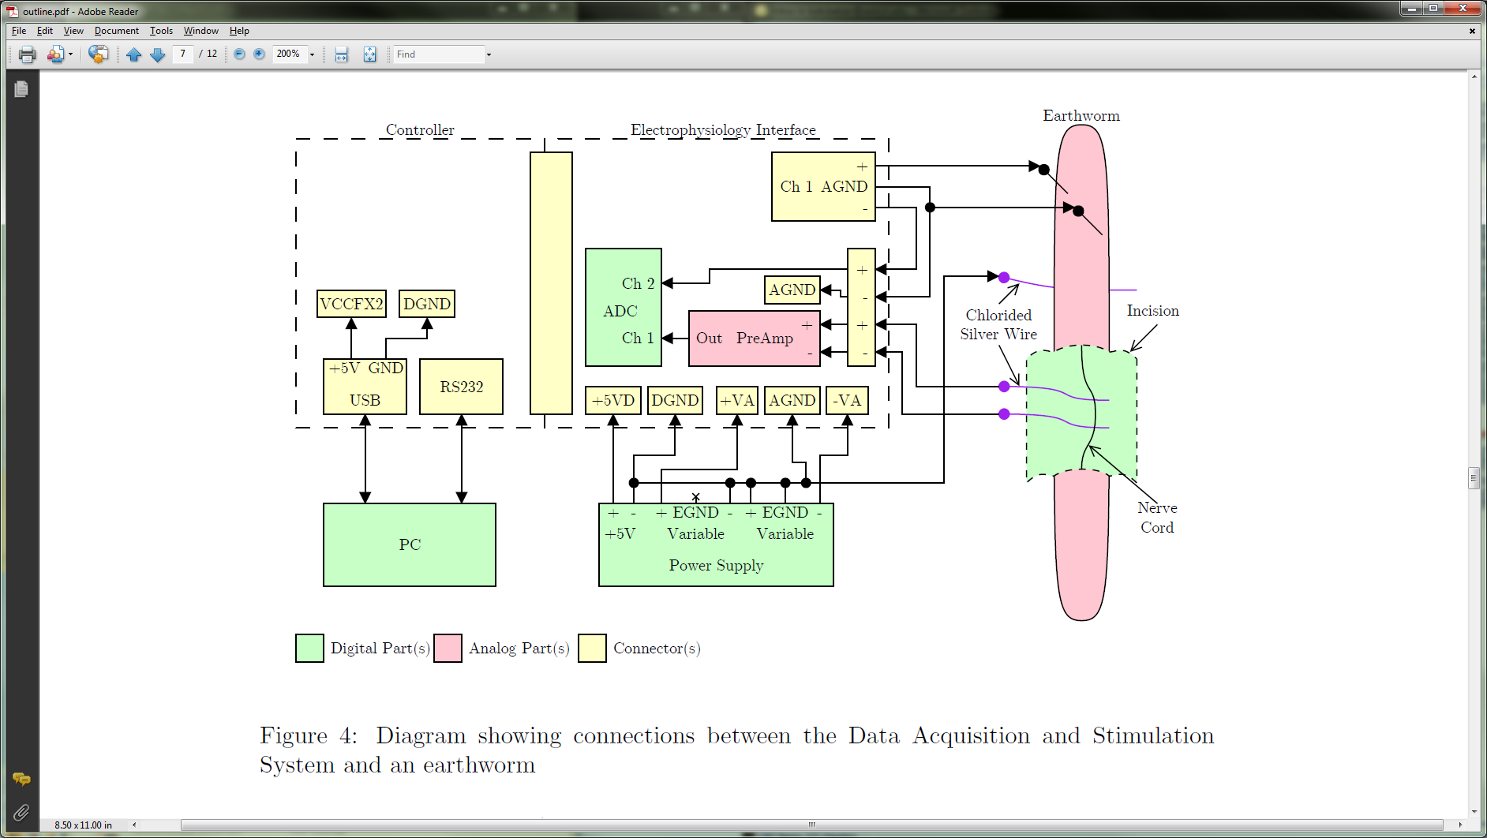

Figure : Connections between the DASS and an earthworm. Illustration by D. Squires [15].

To compare the Data Acquisition and Stimulation System with a previously validated setup, the Preamp from [9, 10], with its output connected to an oscilloscope, has its input connected in parallel with the recording electrodes as shown in Figure 34.

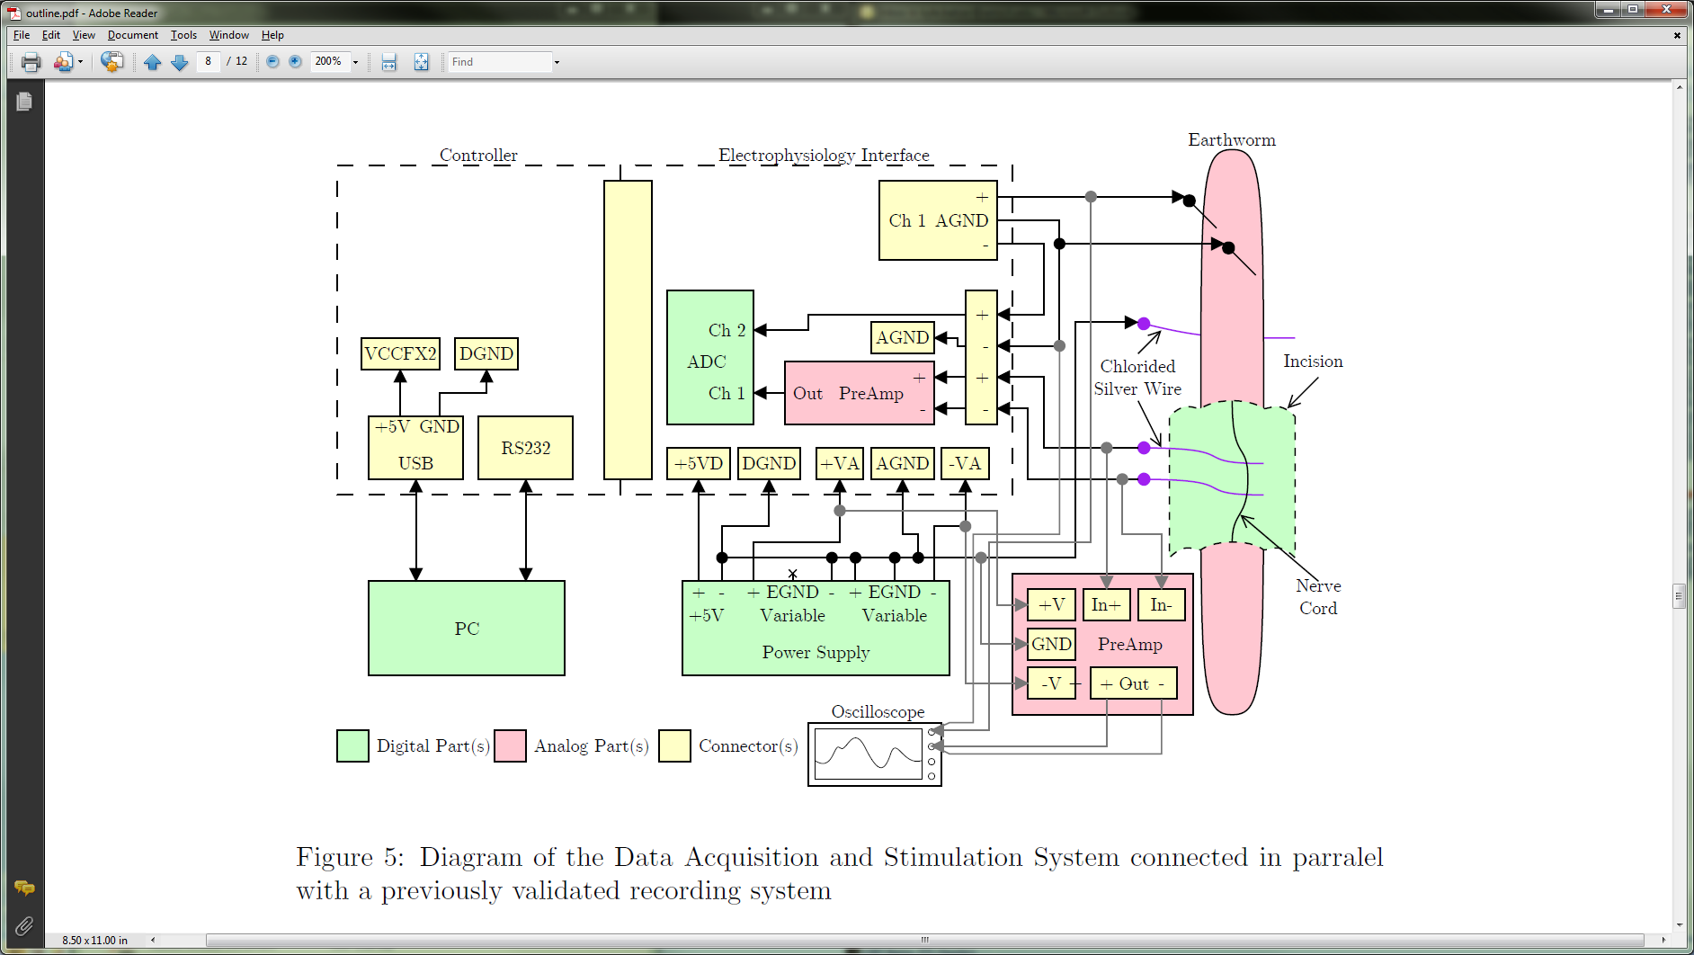

Figure : DASS connected in parallel with a previously validated recording system. Illustration by D. Squires [15].

## Chloriding Silver Wire

The silver wire used for the extracellular electrodes must be coated in a layer of silver chloride. To create the coating, electroplating may be used as described in [13, 25]. A simpler method is to place the portion of the wire that will be in contact with living tissue in full-strength Clorox bleach and leave the wire in the bleach until the wire acquires a purplish-gray tint, which should take between ten and thirty minutes [25].

## Earthworm Experiment Procedure

The earthworm experiment procedure was adapted from [12, 13].

### Earthworm Dissection

* Place the earthworm in a 10% ethanol solution to anesthetize it
* Leave the worm in the ethanol solution for the minimum amount of time needed to make the worm easy to work with while dissecting it; 5-10 minutes may be all that is necessary
* Rinse the earthworm in tap water and pin it, dorsal (dark) side up, on the dissecting dish
* Create a capital-letter-I shaped incision, using surgical scissors, one or two inches long, along the length of the worm, about halfway between the anterior and posterior ends of the earthworm
* Pin the skin to the dissecting dish to expose the worm’s internal anatomy
* Flush the cavity periodically, as needed, with worm Ringer’s solution (in mM units: 102.7 NaCl, 1.6 KCl, 1.8 CaCl2, and 4 NaHCO3 [13]) to make the anatomy easier to view
* Move the intestine aside, using forceps and scissors, exposing the nerve cord
* Free a few centimeters of the nerve cord from its lateral and ventral connections, using the forceps and scissors, to allow the cord to be lifted above and away from the saline and other anatomy
* Position the chloride silver wires under the nerve cord
* Raise the fixture holding the silver wires until the wires and nerve cord are away from the saline and earthworm anatomy (a fraction of an inch is all that is necessary, blowing in the area can break up the surface tension if the saline solution is bridging the wires and cord with the rest of the earthworm)
* Moisten the nerve cord with Ringer’s solution, often, throughout the experiment while making sure that the nerve cord and electrodes remain isolated from the rest of the saline and anatomy (it may be necessary to remove excess Ringer’s solution)

### Electrical Setup

* Place two pins near each other in the anterior end of the earthworm
* Connect the non-inverting output of the stimulation circuit to one pin and connect circuit ground or the inverting output to the second pin
* Connect, optionally, if the inverting output is not connected to a pin in the earthworm, the inverting output of the stimulation circuit to an unused electrode input channel on the Electrophysiology Interface board; ensure that there is no Preamp board in the PCI-Express socket and bypass the socket with a 0Ω resistor. See Figure 33 and Figure 34.
* Place a chloride silver wire under the body of the earthworm, between the stimulation pins and the exposed portion of the earthworm’s body and connect the wire to circuit (which may be earth) ground
* Connect the chloride silver recording electrodes to the Preamp inputs with the non-inverting input connected toward the anterior end of the earthworm and the inverting input connector toward the posterior end (reversing the electrodes will simply invert the signal) (connecting the electrodes may be performed before the silver wires are placed under the nerve cord, to avoid disturbing the electrodes in the process of making the connections)
* Power on the Electrophysiology Interface, first, then power on the RTSC

### Software Setup

* Update FPGA program as described in the **Error! Reference source not found.** appendix.
* Update Cypress EZ-USB firmware as described in the **Error! Reference source not found.** appendix.
* Create the script and corresponding waveform file as shown the **Error! Reference source not found.** appendix.
* Launch Data Acquisition and Stimulation Control Center (DASCC)
* Select the appropriate COM port from the dropdown list
* Select the appropriate Endpoint from the dropdown list, set Packets Per Xfer to 64, and set Xfers to Queue to 64
* Select the Scripting tab and load the Earthworm Script
* When prepared for single stimulus and capture hit the “Run Script” button. Changes to the voltage being output can be modified by changing the 2nd line of the Waveform file, using the **Error! Reference source not found.** appendix as a reference for selecting the appropriate value.
* Graph data by selecting the Graphing tab and hitting the “Load File” button. Once loaded, multiple channels can be displayed at the same time using ctrl + left mouse button to select/deselect channels.
* Click “Output CSV” to export data to a comma-separated value (CSV) text file.

### Stimulation and Recording

* Stimulate the earthworm with a single, 0.2ms wide pulse with low amplitude (less than 1.0V)
* Repeat the stimulation while slowly increasing the pulse amplitude (in steps between 0.1V and 0.5V) until a response is seen between 2ms and 8ms after the stimulation artifact, this is the median giant response
* Save the recorded waveform
* Slowly increase the pulse amplitude, further, until a second response is seen between 6ms and 15ms after the stimulation artifact, this is the lateral giant response
* Save the recorded waveform

## Results

The earthworm experiment was performed with the Data Acquisition and Stimulation System connected in parallel with a preamp and oscilloscope that was validated in [9]. A diagram of the experimental setup is shown in Figure 34. A picture of the experimental setup is shown in Figure 35.

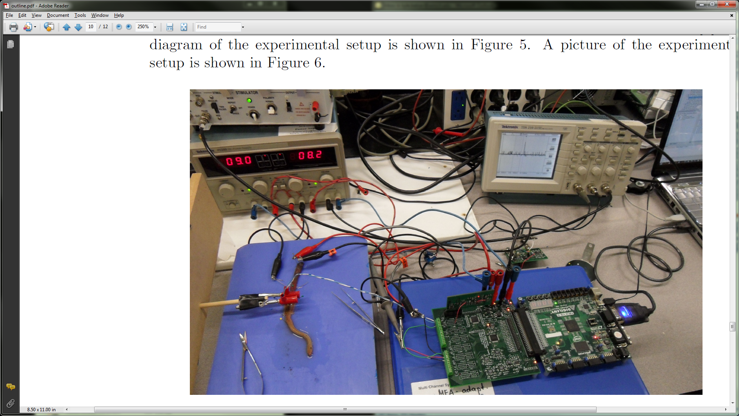

Figure : Picture of the Data Acquisition and Stimulation System connected in parallel with a previously validated recording system

Data recorded from a 2.0V stimulation pulse produced a median giant response similar to those seen in [9] and [14]. The data from the previously validated Preamp and the oscilloscope was plotted on top of the data from the Data Acquisition and Stimulation System. The data from the oscilloscope and the Data Acquisition and Stimulation System can be seen in Figure 36 and the data appears to be in very close agreement.

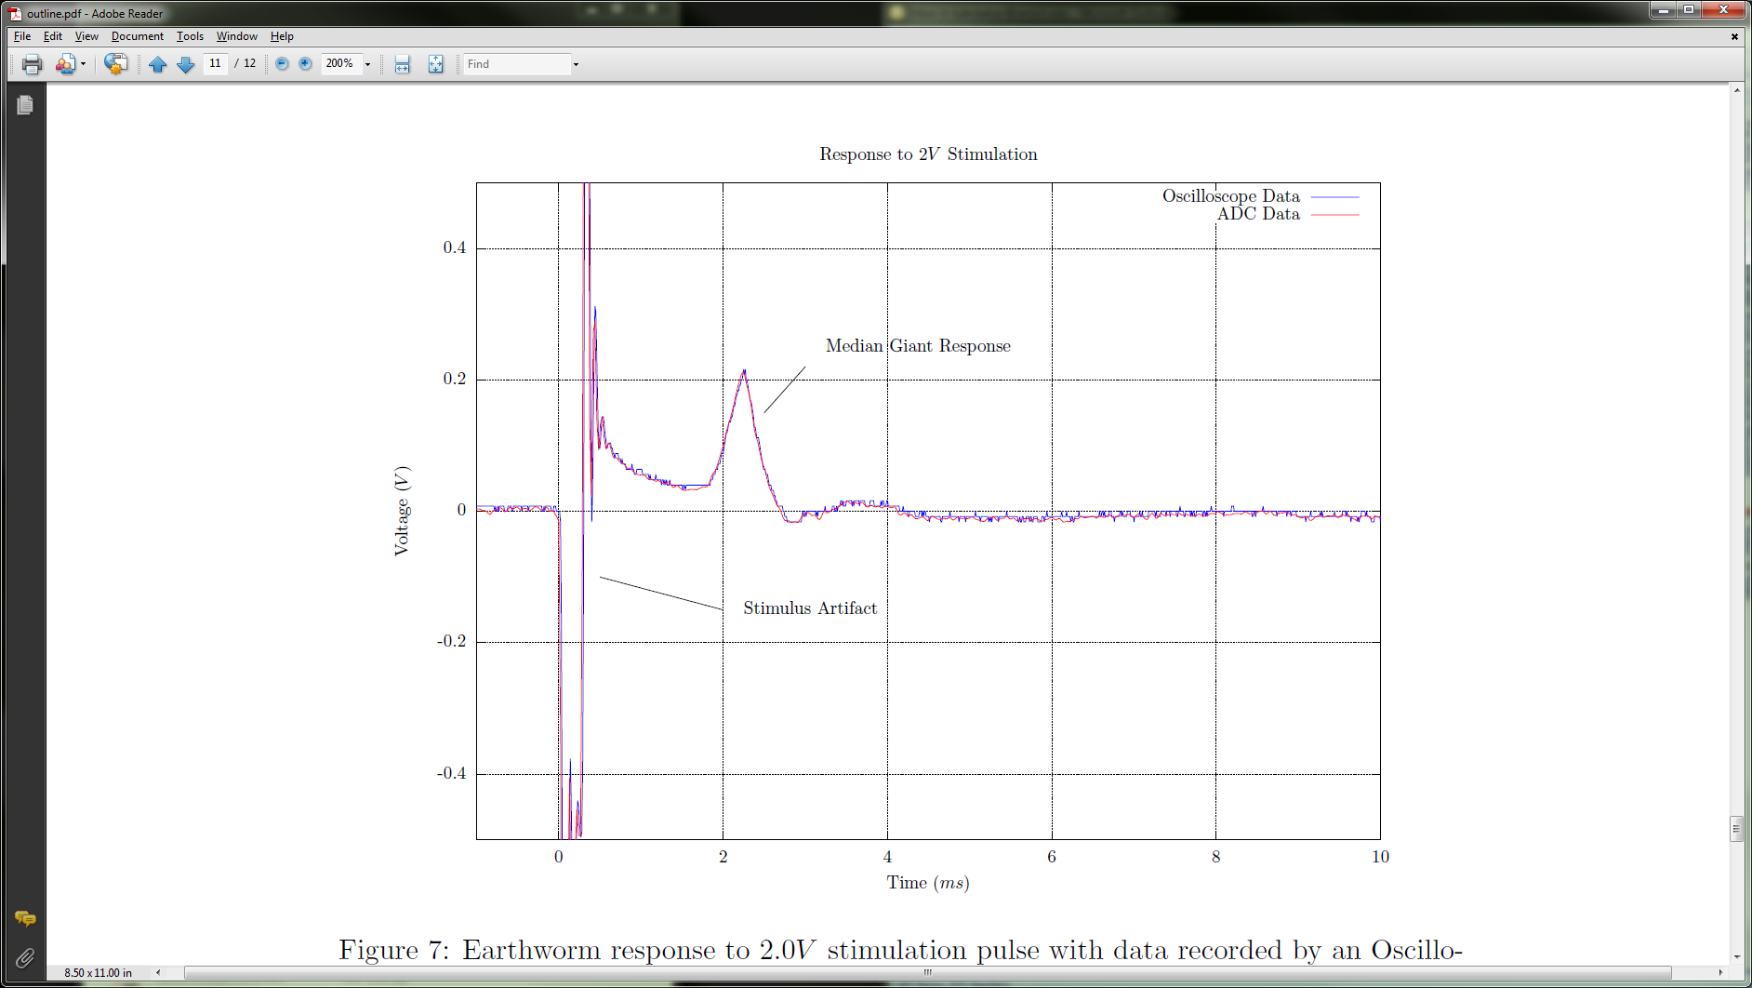

Figure 36: Earthworm response to 2.0V stimulation pulse with data recorded by an Oscilloscope and the Data Acquisition and Stimulation System

Data recorded from a 3.5V stimulation pulse produced median and lateral giant responses similar to those seen in [9] and [14]. The data shown in Figure 37 exhibits close agreement between the Data Acquisition and Stimulation System and the previously validate Preamp.

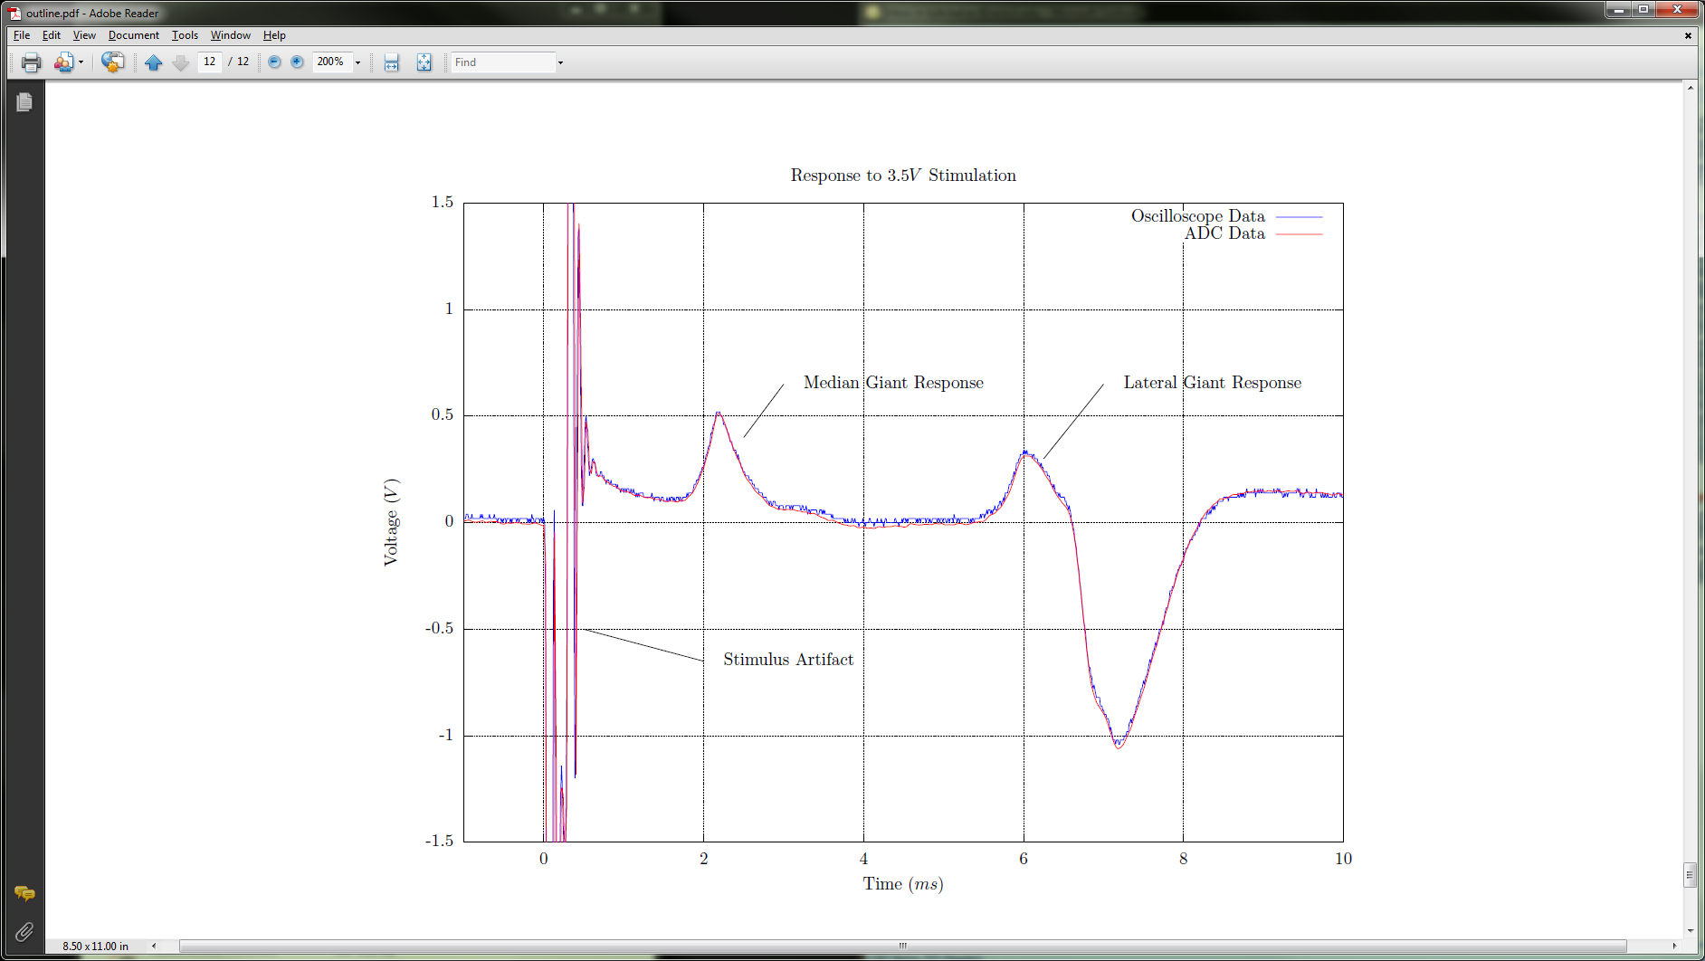

Figure 37: Earthworm response to 3.5V stimulation pulse with data recorded by an Oscilloscope and the Data Acquisition and Stimulation System

# Specifications Review[5]

This section reviews the specifications set forth in the Specifications section and shows how well the Data Acquisition and Stimulation System described in this thesis meets those specifications.

1. Provide a platform for performing electrophysiology experiments with earthworms as described in [12, 13]

Successful accomplishment of the earthworm experiment is shown in section 5.4 of this document.

* 1. Produce a voltage-controlled square wave stimulation pulse with widths from 0.01*ms* to 100*ms* and amplitudes from 0.1*V* to 10*V*

The FPGA and Data Acquisition and Stimulation Control Center (DASCC) are capable of defining a stimulation waveform that updates the DAC output with a period as short as 1us and storing up to 4096 waveform samples with variable sample periods from 1us to 65,536ms. The DAC has a slew rate of 1.5V/us [21] and a differential output voltage range of ±14.8V as shown in [15].

* 1. Produce single stimulation pulses or multiple pulses at rates from 1*Hz* to 10*Hz*

The FPGA and DASCC are capable of defining a stimulation waveform over 1s in length and repeating the waveform indefinitely.

* 1. Provide at least one differential recording channel

There is the potential for up to eight recording channels, each with a Preamp that has a differential input as shown in [15].

* 1. Record an action potential voltage from the time of a stimulation pulse for a minimum duration of 20ms

Data collected for results in the Earthworm Experiment Procedure Results section is more than 1s in duration.

* 1. Plot the recorded voltage

The DASCC is capable of plotting recorded data.

* 1. Store the recorded voltage to a non-proprietary, standard file format

The DASCC is capable of exporting recorded data to a comma separated value (CSV) file.

1. Provide a platform for stimulation and recording of neuron cell culture electrical activity via MEA electrodes

Interfacing the DASS with the MEA is not yet tested.

* 1. Provide at least four recording channels

Eight recording electrodes can be connected to the DASS and stored as digital samples.

* 1. Store data from recording channels continuously

The data recording time limit has not been fully tested.

* 1. Provide at least four voltage-controlled arbitrary stimulation channels

The DASCC is capable of loading an arbitrary waveform, as defined by a text file, into the DASS which outputs the waveform using the AD5678 with four DAC outputs.

* 1. Output single-ended stimulation signals on recording electrodes and add culture voltage offset to the stimulation signal

The stimulation signals are routed to the Preamp boards which output the stimulation signals on the recording electrodes and add the culture voltage offset as described in [15].

* 1. Provide an interface that can specify stimulation waveforms, locations, and intervals that can be updated based on data from the recording electrodes

The DASCC provides a scripting language for defining recording intervals, stimulation waveforms, and stimulation intervals, but does not have provisions for analyzing recorded data and adjusting stimulation strategy.

1. Utilize Low-Noise Amplifier described in [9]

The Low-Noise Amplifier, also known as the Preamp, is successfully utilized with the DASS; though, not all features are tested.

* 1. Connect to each Low-Noise Amplifier channel with a PCI-Express card edge connector

Eight PCI-Express card edge connector sockets are available on the Electrophysiology Interface board as described in [15].

* 1. Provide ±7V to ±15V analog voltage supplies and ground via the card edge connector

The Electrophysiology Interface board connects its analog voltage supply inputs, which tolerate ±7V to ±15V, to the Preamp connectors as described in [15].

* 1. Provide ability to independently switch four digital inputs for each channel, 0IH = 0.8V and 1IL = 2.4V

The CPLD on the Electrophysiology Interface board enables the FPGA to control each digital input on every Preamp channel and voltage compatibility is shown in [15], but a logic configuration for the CPLD is not written.

* 1. Route differential analog input to the card edge connector for each channel

The differential inputs of the Preamps are routed to a terminal block for simple connection to recording electrodes as described in [15].

* 1. Convert the 20Hz to 14.6kHz analog output signal [9] to digital samples

An AD7606 ADC converts the Preamp output voltage to digital samples, has an analog low-pass input filter with a corner frequency of 23kHz, and can sample at up to 200kS/s, satisfying the sampling theorem, as described in [15].

* 1. Route a single-ended stimulation signal to each channel

Four unique stimulation channels with differential outputs are connected single ended to the eight Preamp connectors as described in [15].

# Conclusions

The Data Acquisition and Stimulation System (DASS) provides eight channels of acquisition and four channels of arbitrary waveform generation to support electrophysiology experiments, including basic (earthworm) and advanced (microelectrode array or MEAs) applications. The system is certainly not limited to the considered use cases; its features are likely to align with many other electrophysiological applications not yet investigated. The DASS expands the capabilities of the Neurobiology Engineering Laboratory at Western Michigan University.

**Future Expansion**

One of the major goals of the current design was leaving the architecture open for future expansion. A future target is full support of the 60 channels of a MEA. An initial discussion was provided in [15] of a possible hardware architecture. From a software/firmware perspective the main area of concern is the required acquisition data rates. A 60 channel system with a 188 byte packet size would have 8.2908 Mbytes/s, calculated as:

$Packetized ADC Data= \frac{188 bytes*44100Hz}{1000000}=8.2908 Mbytes/s$.

This data rate exceeds the previously calculated interrupt mode max throughput of 8.192 Mbytes/s, discussed in the Data Flow Analysis section of this document and calculated as:

$Interrupt Mode Bandwidth=1024 bytes* \frac{1}{125 microseconds}=8.192 Mbytes/s$.

Using a different FPGA could provide larger FIFOs and make it possible to not require the 125 microsecond latency that interrupt mode USB transfers provide. With this relinquished, bulk transfers become possible with a maximum theoretical throughput of 60 Mbytes/s. Despite the expectation that the full 60 Mbytes/s would not be achieved, it is reasonable to assume 8.2908 Mbytes/s of sustained bandwidth is achievable.

The FIFO size concern is better understood by reviewing the current amount of unresponsiveness from a Windows PC required to fill the current FIFO. This is calculated as follows:

$Acq. FIFO Fill Time=\frac{\left(\frac{32768 byte FIFO}{32 byte packet}* \frac{1}{44.1kHz}\right)}{1000}=23.22 ms$.

Additionally, the Cypress FIFOs are filled within the following time:

$Cypress FIFO Fill Time=\frac{\left(\frac{4096 byte FIFO}{32 byte packet}* \frac{1}{44.1kHz}\right)}{1000}=2.9025 ms$.

On the PC, the Cypress driver provides further buffering of data, which can be filled within the following time:

$Cypress Driver Fill Time=\frac{\left(\frac{8388608 byte FIFO}{32 byte packet}* \frac{1}{44.1kHz}\right)}{1000}=5944.308 ms$.

Thus there is approximately 6 seconds between being completely empty to completely full across the entire chain. If at any point the USB transactions stop being serviced the RTSC only has approximately 26 milliseconds of buffering capability. As is, it is possible to drop data on an overtaxed Windows PC. Further investigation of the Cypress driver and the way Windows interacts with it for maintaining data transfers would help gain confidence in the DASS data integrity.

Expanding on these buffer fill times for a 60 channel system, the same calculations, but with 188 byte packets taken into account, result in 3.952 milliseconds for Acquisition FIFO fill time, 0.494 ms for Cypress FIFO fill time, and 1011.797 ms Cypress driver fill time. Table 29 summarizes the fill times for the 8 and 60 channel implementations.

|  |  |  |
| --- | --- | --- |
|  | 8 Channel Fill Time (ms) | 60 Channel Fill Time (ms) |
| Acquisition FIFO Fill Time | 23.22 | 3.952 |
| Cypress FIFO Fill Time | 2.9025 | 0.494 |
| Cypress Driver Fill Time | 5944.308 | 1011.797 |

Table : Buffer Fill Time

Given that interrupt mode does not provide sufficient bandwidth, bulk mode does not provide guaranteed latency, and the buffer fill time is less than ~1012 milliseconds for a 60 channel system, the ability to use a single USB 2.0 connection with the current FPGA size is unlikely. Further investigation is required to find a viable solution.

One possible consideration for maintaining the current architecture is a much larger FPGA that would have more BRAM resources, providing a larger FIFO. Another possible improvement would be to move to a USB 3.1 supported chip in the place of the current Cypress EZ-USB chip, effectively increasing the maximum bandwidth to 10Gbps.

Other considerations for future system include use of a Real-Time Operating System (RTOS) alongside the FPGA, providing more deterministic performance for the HDD data logging portion of the project. The Xilinx Zynq chip is one such example where a FPGA fabric and dual-core ARM A9 are provided on the same chip. Logging directly to SSD from the ARM A9, or even directly from an FPGA, would increase possible performance. A network connection could be created providing a Windows PC control over the RTOS/FPGA operation and non real-time feedback / decimated data visualization.

**Personal Development**

This has been a very rewarding project from a personal standpoint. I am happy to have had the opportunity to significantly extend my senior design project [10], from what was a solid baseline (albeit with many issues that made it overall unusable for real experimentation) to a working system for electrophysiological experimentation. This project has provided insight into the challenges of acquiring real-time data and commanding real-time operations from the convenient interface a Windows PC provides. It greatly expanded my knowledge of low-level FPGA development and introduced me to the world of high-level GUI based C# development.

**Closing**

Even though I have many ideas for work that could be done to improve the system as outlined in part here, I am proud to pass this project and architecture on to those to follow. It is a bittersweet concept; one that I am confident my family will find more sweet than bitter provided the many tireless hours spent in pursuit of a functional prototype.

# 

# Appendix A

**GitHub Repository**

A GitHub repository [26] has been created that contains all source and documentation related to this project. This includes the following:

* RTSC FPGA source code
* DASCC PC source code
* Cypress EZ-USB firmware source code
* Description of required software and drivers
* “Getting Started” guide, describing the steps required to get the system operational

## 

# Appendix B

**Programming FPGA**

The FPGA is programmed using Adept from Digilent [19]. It requires the original Digilent firmware to be running on the Cypress CY7C68013A, which is loaded from the I2C CMOS Serial EEPROM (24AA128) whenever power is cycled. This means the USB cable must be unplugged and plugged in to have the original firmware reloaded (toggling the power switch does not cycle power to the Cypress CY7C68013A).

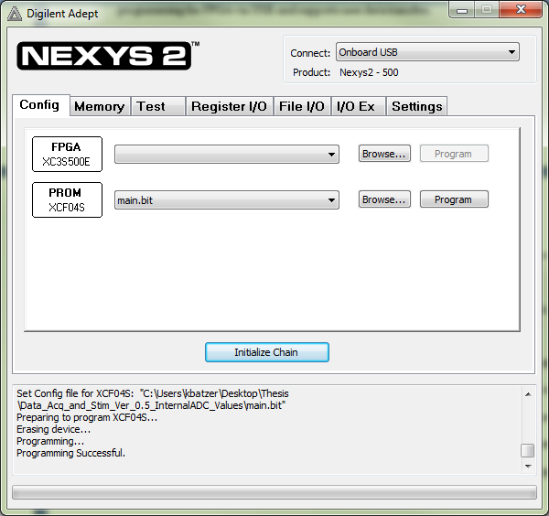

Figure 38: Digilent Adept software used for programming the FPGA

Adept provides a view into the JTAG chain of the Nexys2, which the CY7C68013A commands when programming the FPGA. shows two JTAG targets for programming: the FPGA and PROM. Targeting the FPGA will write to the FPGA RAM and thus programs will only be retained until power is cycled. Targeting the PROM will write to the ROM available on the Nexys2. It is necessary to have the MODE jumper, JP9, set to ROM (pins 2 and 3 connected) to have the FPGA load the program from ROM on power cycle.

For this project, it was desirable to be able to load the program into ROM, allowing the program to be loaded by the FPGA every time power was cycled. To accomplish this, the following steps are required:

1. Launch Adept
2. Unplug the USB Cable and plug it in.
3. In the “Connect” drop down on Adept select “Onboard USB”.
4. On the “Config” tab of Adept push “Browse…” next to the PROM and select the appropriate .bit file.
5. Push Program.
6. Ensure JP9 (Mode Jumper) on the Nexys2 is set to load from ROM and unplug and plug in the USB cable to cycle power to the board.
7. The program should load from ROM when the board finishing power up from the previous step.

## 

# Appendix C

**Programming Cypress EZ-USB (CY7C68013A)**

1. Cycle power to the Nexys2 development board by unplugging and plugging in the USB cable (desired FPGA program should load from EEPROM)
2. Using fx2loader, update to an intermediate firmware that updates the VID:PID to 04B4:8613.
   1. Open cmd prompt and navigate to location of fx2loader.
   2. Type “fx2loader.exe -v 1443:0005 firmware.hex” and press enter.
3. Using CypressProgramUtility update to the desired firmware.
   1. Open cmd prompt and navigate to location of CypressProgramUtility.
   2. Type “ProgramUtility.exe ep2_int_in.hex” and press enter.
4. The firmware is ready to use.

## 

# Appendix D

**DASCC Scripting Amplitude**

DASCC scripting takes hex values from 0x0000 to 0xFFFF. In hardware, the DAC will output 0V to 5V, and the corresponding circuitry will take this single ended output and give -7.5V to 7.5V differential output. The following table provides a set of common amplitude values for quick reference throughout the full range available. For specific voltages not in the table use the function and convert the decimal value to HEX:

$$Decimal Value=\left(Desired Voltage+7.5\right)*\frac{2^{16}}{15}$$

In Excel:

= DEC2HEX((DesiredVoltage + 7.5)*POWER(2,16)/(15))

|  |  |  |  |
| --- | --- | --- | --- |
| Desired Voltage | HEX Value | Desired Voltage | HEX Value |
| -7.5 | 0 | 0.5 | 8888 |
| -7 | 888 | 1 | 9111 |
| -6.5 | 1111 | 1.5 | 9999 |
| -6 | 1999 | 2 | A222 |
| -5.5 | 2222 | 2.5 | AAAA |
| -5 | 2AAA | 3 | B333 |
| -4.5 | 3333 | 3.5 | BBBB |
| -4 | 3BBB | 4 | C444 |
| -3.5 | 4444 | 4.5 | CCCC |
| -3 | 4CCC | 5 | D555 |
| -2.5 | 5555 | 5.5 | DDDD |
| -2 | 5DDD | 6 | E666 |
| -1.5 | 6666 | 6.5 | EEEE |
| -1 | 6EEE | 7 | F777 |
| -0.5 | 7777 | 7.49 | FFFF |
| 0 | 8000 |  |  |

Table : DASCC Scripting Amplitude Hex Value Table

## 

# Appendix E

**Earthworm Script and Waveform**

This section provides the script and waveform file used to perform the earthworm experiment.

The script sends EarthwormWaveform.txt to the RTSC where it is stored in memory for channel one. The acquisition is then started, there is a 400 ms delay, and then the stimulation waveform is output on channel one. There is another 400 ms delay to make sure all response to the stimulus is captured and then the acquisition is stopped.

**Script.txt**

SetWaveform(1,EarthwormWaveform.txt);

StartAcquisition();

Sleep(400);

SingleStim(01);

Sleep(400);

EndAcquisition();

The waveform file contains the amplitude:time pairs to create the desired waveform. The first line places the output at midscale for 100 us. The second line sets the output to 1V for 100 us. The last line returns the output to midscale.

**EarthwormWaveform.txt**

7FFF,0100

9111,0100

7FFF,0100

## 

# Appendix F

**DASCC Scripting Commands**

The DASCC scripting allows the user an easy way to sequence the commands provided by the RTSC Application Programming Interface (API). DASCC scripts are interpreted at runtime.

**SetConfig(Channel, config);**

This command sends Set Channel Configuration with provided channel and configuration.

**GetConfig(channel);**

This command sends for the requested channel.

**StartAcquisition();**

This command sends , enabling acquisition on all channels by setting bit 0 of the Acquisition Register.

**EndAcquisition();**

This command sends , disabling acquisition on all channels by clearing bit 0 of the .

**SingleStim(ChannelMask);**

This command sends Set Stimulation Register, setting the Stimulation Register for a single cycle as specified by the ChannelMask parameter. The result is each channel specified will output its waveform once.

**StartMultiStim(ChannelMask);**

This command sends Set Stimulation Register, setting the Stimulation Register as specified by the ChannelMask parameter. The result is each channel specified will output its waveform repeatedly.

**EndMultiStim(ChannelMask);**

This command sends , clearing the as specified by the ChannelMask parameter. The result is each channel specified will stop outputting its waveform.

**SetWaveform(channel,filename);**

This command sends Set Waveform for the given channel. The provided filename is expected to have amplitude:time pairs in ascii format.

**GetWaveform(channel);**

This command sends for the given channel.

**Sleep(time in milliseconds);**

This command causes the script to wait for the provided number of milliseconds.

## 

# Appendix G

**RTSC FPGA Configuration – Code**

# Appendix H

**Data Acquisition and Stimulation – Code**

**Channels.cs**

using System;

using System.Collections.Generic;

using System.Linq;

using System.Text;

using System.ComponentModel;

namespace Data_Acq_and_Stim_Control_Center

{

/*****************************************************************************************************

* Channels class

*

* contains configuration information for channels

/*****************************************************************************************************/

public class Channels : INotifyPropertyChanged

{

private string _channel;

private string _waveform_file;

private string _mode;

private string _sw1;

private string _sw2;

private string _sw3;

private string _sw4;

public event PropertyChangedEventHandler PropertyChanged;

public Channels(string channel, string waveform_file, string mode)

{

_channel = channel;

_waveform_file = waveform_file;

_mode = mode;

if (mode == "Stimulation")

{

_sw1 = "On";

_sw2 = "On";

_sw3 = "On";

_sw4 = "On";

}

else

{

_sw1 = "Off";

_sw2 = "Off";

_sw3 = "Off";

_sw4 = "Off";

}

}

public string channel

{

get { return _channel; }

set

{

_channel = value;

this.NotifyPropertyChanged("channel");

}

}

public string waveform_file

{

get { return _waveform_file; }

set

{

_waveform_file = value;

this.NotifyPropertyChanged("waveform_file");

}

}

public string mode

{

get { return _mode; }

set

{

_mode = value;

this.NotifyPropertyChanged("mode");

}

}

public string sw1

{

get { return _sw1; }

set

{

_sw1 = value;

this.NotifyPropertyChanged("sw1");

}

}

public string sw2

{

get { return _sw2; }

set

{

_sw2 = value;

this.NotifyPropertyChanged("sw2");

}

}

public string sw3

{

get { return _sw3; }

set

{

_sw3 = value;

this.NotifyPropertyChanged("sw3");

}

}

public string sw4

{

get { return _sw4; }

set

{

_sw4 = value;

this.NotifyPropertyChanged("sw4");

}

}

private void NotifyPropertyChanged(string name)

{

if (PropertyChanged != null)

PropertyChanged(this, new PropertyChangedEventArgs(name));

}

}

}

**CypressDataAcq.cs**

This code was derived from Cypress Streamer 3.4.7.0 available in CySuiteUSB.

**FPGA_Commands.cs**

using System;

using System.Collections.Generic;

using System.Linq;

using System.Text;

using System.Threading;

using System.IO;

namespace Data_Acq_and_Stim_Control_Center

{

public class FPGA_Commands

{

public RS232_Communication RS232_Com;

public FPGA_Commands()

{

RS232_Com = new RS232_Communication();

}

public void FPGA_SetConfig(Byte Channel, Byte Config)

{

byte length_h = 0x00;

byte length_l = 0x07;

byte checksum = 0x00;

// Build Message

byte[] msg = new byte[] { 0x5A, 0x01, length_h, length_l, Channel, Config, checksum };

// Calculate Checksum

for (int j = 0; j < msg.Length - 1; j++)

{

checksum += msg[j];

}

msg[msg.Length - 1] = checksum;

// Send Message

RS232_Com.SendData(msg);

}

public void FPGA_GetConfig(Byte Channel)

{

Byte length_h = 0x00;

Byte length_l = 0x06;

Byte checksum = 0x00;

// Build Message

byte[] msg = new byte[] { 0x5A, 0x02, length_h, length_l, Channel, checksum };

// Calculate Checksum

for (int j = 0; j < msg.Length - 1; j++)

{

checksum += msg[j];

}

msg[msg.Length - 1] = checksum;

// Send Message

RS232_Com.SendData(msg);

}

public void FPGA_SetWaveform(Byte Channel, string Filename)

{

List<Byte> wave_data = new List<Byte>();

try

{

using (StreamReader sr = new StreamReader(Filename))

{

String line;

String[] split_str = new String[2];

while ((line = sr.ReadLine()) != null)

{

//this.Dispatcher.Invoke(DispatcherPriority.Normal, (Action)(() =>

//{

// textBox1.AppendText(line + "\r\n");

//}));

split_str = line.Split(',');

string temp1 = split_str[0].Substring(0, 2);

string temp2 = split_str[0].Substring(2, 2);

string temp3 = split_str[1].Substring(0, 2);

string temp4 = split_str[1].Substring(2, 2);

wave_data.Add(Convert.ToByte((ToNibble(temp1[0]) << 4) + ToNibble(temp1[1])));

wave_data.Add(Convert.ToByte((ToNibble(temp2[0]) << 4) + ToNibble(temp2[1])));

wave_data.Add(Convert.ToByte((ToNibble(temp3[0]) << 4) + ToNibble(temp3[1])));

wave_data.Add(Convert.ToByte((ToNibble(temp4[0]) << 4) + ToNibble(temp4[1])));

//port.WriteLine();

}

}

byte[] newarray = wave_data.ToArray();

byte[] msg_buf = new byte[7 + wave_data.Count];

msg_buf[0] = 0x5A; // Start Byte

msg_buf[1] = 0x05; // MSG_ID

msg_buf[2] = 0x00; // Length_High

msg_buf[3] = Convert.ToByte(7 + wave_data.Count); // Length_Low

msg_buf[4] = Channel; // Channel

msg_buf[5] = Convert.ToByte(wave_data.Count / 4); // Samples

newarray.CopyTo(msg_buf, 6);

msg_buf[msg_buf[3] - 1] = 0xFF;

// Send Message

RS232_Com.SendData(msg_buf);

}

catch { }

}

public void FPGA_GetWaveform(Byte Channel)

{

byte length_h = 0x00;

byte length_l = 0x06;

//byte channel = Convert.ToByte(setWaveChan_CB.SelectedIndex + 1);

byte checksum = 0x00;

// Build Message

byte[] msg_buf = new byte[] { 0x5A, 0x06, length_h, length_l, Channel, checksum };

// Calculate Checksum

for (int j = 0; j < msg_buf.Length - 1; j++)

{

checksum += msg_buf[j];

}

msg_buf[msg_buf.Length - 1] = checksum;

// Send Message

RS232_Com.SendData(msg_buf);

}

public void FPGA_StartAcquisition()

{

// Adding call to start cypress acquisition

//MainWindow.CypressDA.Start_Cypress_Acq();

//Start_Cypress_Acq();

// Temporary Start Acq

byte[] temp_start_msg = new byte[] { 0x5A, 0x01, 0x00, 0x07, 0x01, 0x9F, 0xFF };

// Send command

RS232_Com.SendData(temp_start_msg);

}

public void FPGA_EndAcquisition()

{

// Adding call to stop cypress acquisition

//MainWindow.CypressDA.Stop_Cypress_Acq();

//Stop_Cypress_Acq();

// Temporary Start Acq

byte[] temp_end_msg = new byte[] { 0x5A, 0x01, 0x00, 0x07, 0x01, 0x1F, 0xFF };

// Send command

RS232_Com.SendData(temp_end_msg);

}

public void FPGA_StartMultiStim(Byte Channel)

{

byte length_h = 0x00;

byte length_l = 0x07;

byte continuous = Channel;

byte checksum = 0x00;

// Build Message

byte[] msg = new byte[] { 0x5A, 0x07, length_h, length_l, Channel, continuous, checksum };

// Calculate Checksum

for (int j = 0; j < msg.Length - 1; j++)

{

checksum += msg[j];

}

msg[msg.Length - 1] = checksum;

// Send Message

RS232_Com.SendData(msg);

}

public void FPGA_EndMuliStim()

{

byte length_h = 0x00;

byte length_l = 0x07;

byte channel = 0x00;

byte continuous = 0x00;

byte checksum = 0x00;

// Build Message

byte[] msg = new byte[] { 0x5A, 0x07, length_h, length_l, channel, continuous, checksum };

// Calculate Checksum

for (int j = 0; j < msg.Length - 1; j++)

{

checksum += msg[j];

}

msg[msg.Length - 1] = checksum;

// Send Message

RS232_Com.SendData(msg);

}

public void FPGA_SingleStim(Byte Channel)

{

byte length_h = 0x00;

byte length_l = 0x07;

byte continuous = 0x00;

byte checksum = 0x00;

// Build Message

byte[] msg = new byte[] { 0x5A, 0x07, length_h, length_l, Channel, continuous, checksum };

// Calculate Checksum

for (int j = 0; j < msg.Length - 1; j++)

{

checksum += msg[j];

}

msg[msg.Length - 1] = checksum;

// Send Message

RS232_Com.SendData(msg);

}

private byte ToNibble(char c)

{

if ('0' <= c && c <= '9') { return Convert.ToByte(c - '0'); }

else if ('a' <= c && c <= 'f') { return Convert.ToByte(c - 'a' + 10); }

else if ('A' <= c && c <= 'F') { return Convert.ToByte(c - 'A' + 10); }

else

{

throw new ArgumentException(String.Format("Character '{0}' cannot be translated to a hexadecimal value because it is not one of 0,1,2,3,4,5,6,7,8,9,a,b,c,d,e,f,A,B,C,D,E,F", c));

}

}

}

}

**Graphing.cs**

using System;

using System.Collections.Generic;

using System.Linq;

using System.Text;

using System.Collections;

using System.Windows;

using System.IO;

using System.ComponentModel;

namespace Data_Acq_and_Stim_Control_Center

{

public class Graphing : INotifyPropertyChanged

{

#region graphing globals

public List<int> SupportedNumSamples = new List<int>();

//static int NUM_CHANNELS_GRAPH = 8;

static int NUM_PACKETS = 65536;

//static int NUM_SAMPLES_DISPLAYED = 32768 / 4;

static int previous_view = 0;

Double time_from_start = 0;

Double prev_time_calc = 0;

//GraphingData Channel1_Data = new GraphingData();

public List<GraphingData> GraphData = new List<GraphingData>();

#endregion

private int _SamplesPerView;

public int SamplesPerView

{

get { return _SamplesPerView; }

set

{

_SamplesPerView = value;

this.NotifyPropertyChanged("SamplesPerView");

}

}

private int _TotalViews;

public int TotalViews

{

get { return _TotalViews; }

set

{

_TotalViews = value;

this.NotifyPropertyChanged("TotalViews");

}

}

private int _CurrentView;

public int CurrentView

{

get { return _CurrentView; }

set

{

_CurrentView = value;

this.NotifyPropertyChanged("CurrentView");

}

}

private int _ChannelsToGraph;

public int ChannelsToGraph

{

get { return _ChannelsToGraph; }

set

{

_ChannelsToGraph = value;

this.NotifyPropertyChanged("ChannelsToGraph");

}

}

public event PropertyChangedEventHandler PropertyChanged;

private void NotifyPropertyChanged(string name)

{

if (PropertyChanged != null)

PropertyChanged(this, new PropertyChangedEventArgs(name));

}

#region graphing code

public Graphing()

{

SupportedNumSamples.Add(512);

SupportedNumSamples.Add(1024);

SupportedNumSamples.Add(2048);

SupportedNumSamples.Add(4096);

SupportedNumSamples.Add(8192);

SupportedNumSamples.Add(16384);

}

public void LoadFile()

{

Stream myStream = null;

Int16 val;

UInt32 time_offset;

//Int16[] channel = new Int16[NUM_CHANNELS];

Double time_calc;

int pos = 0;

string packet_display = "";

Int32 buffer_loc = 0;

Double SampleCount = 0;

// Show the dialog and get result.

Microsoft.Win32.OpenFileDialog openFileDialog1 = new Microsoft.Win32.OpenFileDialog();

bool? result = openFileDialog1.ShowDialog();

if (result == true) // Test result.

{

if ((myStream = openFileDialog1.OpenFile()) != null)

{

foreach (GraphingData data in GraphData)

{

data.Channel_AllData.Collection.Clear();

}

//textBox1.AppendText(openFileDialog1.FileName + " Opened Successfully! File Size: " + myStream.Length + "\r\n"); // <-- For debugging use only.

//myStream.Length

byte[] buffer = new byte[myStream.Length];

// buffer_loc += 32 * NUM_PACKETS;

while (buffer_loc < myStream.Length)

{

//myStream.Read(buffer,

myStream.Read(buffer, 0, NUM_PACKETS);

byte[] packet = new byte[32];

while (pos < NUM_PACKETS)

{

// packet_display = "";

Array.Copy(buffer, pos, packet, 0, 32);

/*for (int i = 0; i < 32; i++)

{

packet[i] = buffer[i + pos];

//textBox1.AppendText(packet[i].ToString("X") + " ");

//packet_display += packet[i].ToString("X") + " ";

}*/

val = BitConverter.ToInt16(packet, 0);

time_offset = BitConverter.ToUInt32(packet, 2);

time_calc = time_offset * .00000002;

if (SampleCount == 0)

{

time_from_start = time_calc;

prev_time_calc = time_calc;

}

else if (time_calc < prev_time_calc)

{

time_from_start += (4294967296 * .00000002 - prev_time_calc) + time_calc;

prev_time_calc = time_calc;

}

else

{

time_from_start += time_calc - prev_time_calc;

prev_time_calc = time_calc;

}

//textBox1.AppendText("\r\n\r\nTimeOffset: " + time_calc.ToString("00.000000"));

// packet_display += "\r\nTimeOffset: " + time_calc.ToString("00.000000");

for (int i = 0; i < ChannelsToGraph; i++)

{

Int16 raw_voltage = BitConverter.ToInt16(packet, 7 + i * 3);

//textBox1.AppendText("\tChannel" + i.ToString() + ": " + (channel[i] / 32768.0 * 5.0).ToString("0.000") + "V\t");

// packet_display += "\tChannel" + i.ToString() + ": " + (channel[i] / 32768.0 * 5.0).ToString("0.000") + "V\t";

if (raw_voltage == 0) { raw_voltage = 1; }

Point p1 = new Point(time_from_start, raw_voltage / 32768.0 * 10.0);

GraphData[i].Channel_AllData.Collection.Add(p1);

}

//textBox1.AppendText(packet_display + "\r\n\r\n");

//Point p1 = new Point(time_from_start, channel[0] / 32768.0 * 5.0);

//Point p1 = new Point(SampleCount, channel[0] / 32768.0 * 5.0);

//Point p1 = new Point(SampleCount, SampleCount);

//Channel1_Data.AppendAsync(Dispatcher, p1);

//Channel1_Data.Channel_AllData.Collection.Add(p1);

//Channel1_Data.Collection.Add(p1);

// Thread.Sleep(5);

pos += 32;

SampleCount++;

//plotter.Viewport.FitToView();

}

buffer_loc += NUM_PACKETS;

pos = 0;

if (buffer_loc > myStream.Length)

{

}

}

}

myStream.Close();

//System.Text.Encoding.

/*foreach (Channels temp in Graph_DataGrid.SelectedItems)

{

string channel_name = temp.channel;

string[] split = channel_name.Split(' ');

int index = Convert.ToInt16(split[1]) - 1;

Point[] AllPoints = GraphData[index].Channel_AllData.Collection.ToArray();

Point[] GraphPoints = new Point[NUM_SAMPLES_DISPLAYED];

Array.Copy(AllPoints, AllPoints.Length - NUM_SAMPLES_DISPLAYED, GraphPoints, 0, NUM_SAMPLES_DISPLAYED);

GraphData[index].Channel_GraphData.Collection.AddMany(GraphPoints);

}*/

//plotter.Children.RemoveAll<LineGraph>();

//foreach (GraphingData data in GraphData)

//{

// plotter.AddLineGraph(data.Channel_GraphData);

//data.SetAllPointArray();

// }

//Graph_DataGrid.SelectedIndex = 0;

//chan1Points = Channel1_Data.Channel_AllData.Collection.ToArray();

// Point[] points = new Point[NUM_SAMPLES_DISPLAYED];

//Array.Copy(chan1Points, chan1Points.Length - NUM_SAMPLES_DISPLAYED, points, 0, NUM_SAMPLES_DISPLAYED);

// Channel1_Data.Channel_GraphData.Collection.AddMany(points);

//plotter.AddLineGraph(Channel1_Data.Channel_GraphData, 2, "Data row 1");

//plotter.AddLineGraph(Channel1_Data, 2, "Data row 1");

}

}

//private void Graph_DataGrid_SelectionChanged(object sender, SelectionChangedEventArgs e)

//{

// int selected_view = Convert.ToInt16(slider1.Value);

// plotter.Children.RemoveAll<LineGraph>();

// foreach (GraphingData data in GraphData)

// {

// data.Channel_GraphData.Collection.Clear();

// }

// foreach (Channels temp in Graph_DataGrid.SelectedItems)

// {

// string channel_name = temp.channel;

// string[] split = channel_name.Split(' ');

// int index = Convert.ToInt16(split[1]) - 1;

// Point[] AllPoints = GraphData[index].Channel_AllData.Collection.ToArray();

// Point[] GraphPoints = new Point[NUM_SAMPLES_DISPLAYED];

// Array.Copy(AllPoints, selected_view * NUM_SAMPLES_DISPLAYED, GraphPoints, 0, NUM_SAMPLES_DISPLAYED);

// //GraphData[index].Channel_GraphData.Collection.Clear();

// GraphData[index].Channel_GraphData.AppendMany(GraphPoints);

// plotter.AddLineGraph(GraphData[index].Channel_GraphData, 1, temp.channel);

// }

// plotter.FitToView();

//}

//private void slider1_ValueChanged(object sender, RoutedPropertyChangedEventArgs<double> e)

//{

// int selected_view = Convert.ToInt16(slider1.Value);

// ViewSelect_TextBox.Text = Convert.ToInt16(slider1.Value).ToString();

// if (selected_view != previous_view)

// {

// // chan1Points = Channel1_Data.Collection.ToArray();

// //Point[] points = new Point[NUM_SAMPLES_DISPLAYED];

// //Array.Copy(chan1Points, selected_view * NUM_SAMPLES_DISPLAYED, points, 0, NUM_SAMPLES_DISPLAYED);

// //Channel1_Data.Channel_GraphData.Collection.Clear();

// //Channel1_Data.Channel_GraphData.AppendMany(points);

// foreach (GraphingData data in GraphData)

// {

// data.Channel_GraphData.Collection.Clear();

// }

// foreach (Channels temp in Graph_DataGrid.SelectedItems)

// {

// string channel_name = temp.channel;

// string[] split = channel_name.Split(' ');

// int index = Convert.ToInt16(split[1]) - 1;

// Point[] AllPoints = GraphData[index].Channel_AllData.Collection.ToArray();

// Point[] GraphPoints = new Point[NUM_SAMPLES_DISPLAYED];

// Array.Copy(AllPoints, selected_view * NUM_SAMPLES_DISPLAYED, GraphPoints, 0, NUM_SAMPLES_DISPLAYED);

// //GraphData[index].Channel_GraphData.Collection.Clear();

// GraphData[index].Channel_GraphData.AppendMany(GraphPoints);

// }

// plotter.FitToView();

// }

// previous_view = selected_view;

//}

#endregion

}

}

**GraphingData.cs**

using System;

using System.Collections.Generic;

using System.Linq;

using System.Text;

using Microsoft.Research.DynamicDataDisplay.DataSources;

using System.Windows;

namespace Data_Acq_and_Stim_Control_Center

{

public class GraphingData

{

public ObservableDataSource<Point> Channel_AllData = null;

public ObservableDataSource<Point> Channel_GraphData = null;

public GraphingData()

{

Channel_AllData = new ObservableDataSource<Point>();

Channel_GraphData = new ObservableDataSource<Point>();

Channel_GraphData.SetXYMapping(p => p);

}

}

}

**MainWindow.xaml**

<Window x:Class="Data_Acq_and_Stim_Control_Center.MainWindow"

xmlns="http://schemas.microsoft.com/winfx/2006/xaml/presentation"

xmlns:x="http://schemas.microsoft.com/winfx/2006/xaml"

xmlns:col="clr-namespace:System.Collections;assembly=mscorlib"

xmlns:sys="clr-namespace:System;assembly=mscorlib"

xmlns:d3="http://research.microsoft.com/DynamicDataDisplay/1.0"

Title="MainWindow" Height="768" Width="1024" Closing="Window_Closing">

<Grid>

<Grid.RowDefinitions>

<RowDefinition Height="265" />

<RowDefinition Height="247*" />

<RowDefinition Height="Auto" />

</Grid.RowDefinitions>

<Grid.ColumnDefinitions>

<ColumnDefinition Width="257" />

<ColumnDefinition Width="497*" />

<ColumnDefinition Width="307" />

</Grid.ColumnDefinitions>

<GroupBox Header="Channel Configuration" HorizontalAlignment="Stretch" Name="groupBox1" VerticalAlignment="Stretch" Grid.Row="0" Grid.Column="1">

<DataGrid HorizontalAlignment="Stretch" Name="dataGrid1" VerticalAlignment="Stretch" AutoGenerateColumns="False" CanUserSortColumns="False" BeginningEdit="dataGrid1_BeginningEdit">

<DataGrid.Columns>

<DataGridTextColumn Header="Channel #" Binding="{Binding Path=channel}" IsReadOnly="True"></DataGridTextColumn>

<DataGridTextColumn Header="Waveform File" Binding="{Binding Path=waveform_file}"></DataGridTextColumn>

<DataGridComboBoxColumn Header="Mode" SelectedItemBinding="{Binding Path=mode}">

<DataGridComboBoxColumn.ItemsSource>

<col:ArrayList>

<sys:String>Acquisition</sys:String>

<sys:String>Stimulation</sys:String>

</col:ArrayList>

</DataGridComboBoxColumn.ItemsSource>

</DataGridComboBoxColumn>

<DataGridComboBoxColumn Header="Switch 1" SelectedItemBinding="{Binding Path=sw1}" >

<DataGridComboBoxColumn.ItemsSource>

<col:ArrayList>

<sys:String>On</sys:String>

<sys:String>Off</sys:String>

</col:ArrayList>

</DataGridComboBoxColumn.ItemsSource>

</DataGridComboBoxColumn>

<DataGridComboBoxColumn Header="Switch 2" SelectedItemBinding="{Binding Path=sw2}">

<DataGridComboBoxColumn.ItemsSource>

<col:ArrayList>

<sys:String>On</sys:String>

<sys:String>Off</sys:String>

</col:ArrayList>

</DataGridComboBoxColumn.ItemsSource>

</DataGridComboBoxColumn>

<DataGridComboBoxColumn Header="Switch 3" SelectedItemBinding="{Binding Path=sw3}">

<DataGridComboBoxColumn.ItemsSource>

<col:ArrayList>

<sys:String>On</sys:String>

<sys:String>Off</sys:String>

</col:ArrayList>

</DataGridComboBoxColumn.ItemsSource>

</DataGridComboBoxColumn>

<DataGridComboBoxColumn Header="Switch 4" SelectedItemBinding="{Binding Path=sw4}">

<DataGridComboBoxColumn.ItemsSource>

<col:ArrayList>

<sys:String>On</sys:String>

<sys:String>Off</sys:String>

</col:ArrayList>

</DataGridComboBoxColumn.ItemsSource>

</DataGridComboBoxColumn>

</DataGrid.Columns>

</DataGrid>

</GroupBox>

<GroupBox Header="Setup" HorizontalAlignment="Stretch" Name="groupBox2" VerticalAlignment="Stretch" Grid.Row="0" Grid.Column="0">

<Grid>

<!-- <Grid.ColumnDefinitions>

<ColumnDefinition/>

<ColumnDefinition/>

</Grid.ColumnDefinitions>

<Grid.RowDefinitions>

<RowDefinition />

<RowDefinition />

<RowDefinition />

<RowDefinition />

<RowDefinition />

</Grid.RowDefinitions>-->

<Label Content="Active Channels" Height="29" Name="label1" Width="96" HorizontalAlignment="Center" VerticalAlignment="Top" Margin="6,27,142,0" />

<ComboBox Height="23" HorizontalAlignment="Center" Name="channels_CB" VerticalAlignment="Top" Width="58" SelectionChanged="channels_CB_SelectionChanged" Margin="179,29,8,0">

<ComboBoxItem>1</ComboBoxItem>

<ComboBoxItem>2</ComboBoxItem>

<ComboBoxItem>3</ComboBoxItem>

<ComboBoxItem>4</ComboBoxItem>

<ComboBoxItem>5</ComboBoxItem>

<ComboBoxItem>6</ComboBoxItem>

<ComboBoxItem>7</ComboBoxItem>

<ComboBoxItem>8</ComboBoxItem>

</ComboBox>

<Label Content="COM Port" Height="29" Name="label2" Width="96" HorizontalAlignment="Center" VerticalAlignment="Top" Margin="6,0,144,0" />

<Button Content="Send Configuration to FPGA" Height="23" HorizontalAlignment="Center" Name="SendConfig_Button" VerticalAlignment="Top" Width="183" Click="SendConfig_Button_Click" Margin="30,124,32,0" />

<ComboBox ItemsSource="{Binding}" Height="23" HorizontalAlignment="Center" Name="com_CB" VerticalAlignment="Top" Width="58" SelectionChanged="com_CB_SelectionChanged" Margin="179,3,8,0">

<!--<ComboBoxItem>COM3</ComboBoxItem>

<ComboBoxItem>COM4</ComboBoxItem>-->

</ComboBox>

<Button Content="Start Acquisition" Height="23" HorizontalAlignment="Center" Name="acq_button" VerticalAlignment="Top" Width="182" Click="acq_button_Click" Margin="30,152,33,0" />

<Button Content="Set Waveform" Height="23" HorizontalAlignment="Center" Name="setWave_button" VerticalAlignment="Top" Width="91" Click="setWave_button_Click" Margin="122,95,32,0" />

<ComboBox Height="23" HorizontalAlignment="Center" Name="setWaveChan_CB" VerticalAlignment="Center" Width="120" Margin="117,58,8,161" />

<Button Content="Get Waveform" Height="23" HorizontalAlignment="Center" Name="getWave_button" VerticalAlignment="Bottom" Width="91" Click="getWave_button_Click" Margin="30,0,124,124" />

<Label Content="Send to .................." Height="28" HorizontalAlignment="Left" Margin="6,55,0,0" Name="label8" VerticalAlignment="Top" />

<Button Content="Start Multi-Stim" Height="23" HorizontalAlignment="Left" Margin="30,184,0,0" Name="StartMuliStim_Button" VerticalAlignment="Top" Width="91" Click="StartMuliStim_Button_Click" />

<Button Content="End Multi-Stim" Height="23" HorizontalAlignment="Left" Margin="122,184,0,0" Name="EndMuliStim_Button" VerticalAlignment="Top" Width="90" Click="EndMuliStim_Button_Click" />

<Button Content="Single Stim" Height="23" HorizontalAlignment="Left" Margin="30,211,0,0" Name="SingleStim_Button" VerticalAlignment="Top" Width="182" Click="SingleStim_Button_Click" />

</Grid>

</GroupBox>

<TabControl Grid.Column="2" HorizontalAlignment="Stretch" Name="tabControl1" VerticalAlignment="Stretch" >

<TabItem Header="Cypress USB Controls" Name="tabItem1">

<Grid>

<Label Content="Endpoint....." Height="28" HorizontalAlignment="Left" Margin="6,9,0,0" Name="label3" VerticalAlignment="Top" Width="74"/>

<ComboBox Height="23" HorizontalAlignment="Left" Margin="86,11,0,0" Name="EndPointsComboBox" VerticalAlignment="Top" Width="203" SelectionChanged="EndPointsComboBox_SelectionChanged" />

<Label Content="Packets Per Xfer" Height="28" HorizontalAlignment="Left" Margin="6,43,0,0" Name="label4" VerticalAlignment="Top" />

<ComboBox Height="23" HorizontalAlignment="Left" Margin="169,43,0,0" Name="PpxBox" VerticalAlignment="Top" Width="120">

<ComboBoxItem>1</ComboBoxItem>

<ComboBoxItem>2</ComboBoxItem>

<ComboBoxItem>4</ComboBoxItem>

<ComboBoxItem>8</ComboBoxItem>

<ComboBoxItem>16</ComboBoxItem>

<ComboBoxItem>32</ComboBoxItem>

<ComboBoxItem>64</ComboBoxItem>

<ComboBoxItem>128</ComboBoxItem>

</ComboBox>

<Label Content="Xfers to Queue" Height="28" HorizontalAlignment="Left" Margin="6,77,0,0" Name="label5" VerticalAlignment="Top" />

<ComboBox Height="23" HorizontalAlignment="Left" Margin="169,77,0,0" Name="QueueBox" VerticalAlignment="Top" Width="120">

<ComboBoxItem>1</ComboBoxItem>

<ComboBoxItem>2</ComboBoxItem>

<ComboBoxItem>4</ComboBoxItem>

<ComboBoxItem>8</ComboBoxItem>

<ComboBoxItem>16</ComboBoxItem>

<ComboBoxItem>32</ComboBoxItem>

<ComboBoxItem>64</ComboBoxItem>

<ComboBoxItem>128</ComboBoxItem>

</ComboBox>

<Label Content="Successes" Height="28" HorizontalAlignment="Left" Margin="6,117,0,0" Name="label6" VerticalAlignment="Top" />

<Label Content="Failures" Height="28" HorizontalAlignment="Left" Margin="151,117,0,0" Name="label7" VerticalAlignment="Top" />

<TextBox Height="23" HorizontalAlignment="Left" Margin="74,120,0,0" Name="SuccessBox" VerticalAlignment="Top" Width="71" />

<TextBox Height="23" HorizontalAlignment="Left" Margin="207,120,0,0" Name="FailuresBox" VerticalAlignment="Top" Width="71" />

<GroupBox Header="Throughput (KB/s)" Height="63" HorizontalAlignment="Left" Margin="6,153,0,0" Name="groupBox5" VerticalAlignment="Top" Width="283">

<Grid>

<ProgressBar Height="10" HorizontalAlignment="Left" Margin="6,8,0,0" Name="ProgressBar" VerticalAlignment="Top" Width="259" />

<Label Content="Label" Height="28" HorizontalAlignment="Left" Margin="74,15,0,0" Name="ThroughputLabel" VerticalAlignment="Top" Width="128" HorizontalContentAlignment="Center" />

</Grid>

</GroupBox>

</Grid>

</TabItem>

<TabItem Header="Scripting" Name="tabItem2">

<Grid>

<Grid.RowDefinitions>

<RowDefinition Height="186*" />

<RowDefinition Height="47*" />

</Grid.RowDefinitions>

<TextBox Text="{Binding Path=ScriptText}" HorizontalAlignment="Stretch" Name="script_Textbox" VerticalAlignment="Stretch" AcceptsReturn="True" AcceptsTab="True" VerticalScrollBarVisibility="Auto" TextWrapping="Wrap"/>

<Button Content="Run Script" Grid.Row="1" Height="23" HorizontalAlignment="Center" Name="RunScript_Button" VerticalAlignment="Center" Width="75" Click="RunScript_Button_Click" Margin="107,12,115,12" />

<Button Content="Load Script" Grid.Row="1" Height="23" HorizontalAlignment="Left" Name="LoadScript_Button" VerticalAlignment="Center" Width="75" Click="LoadScript_Button_Click" />

<Button Content="Save Script As" Grid.Row="1" Height="23" HorizontalAlignment="Right" Name="SaveAsScript_Button" VerticalAlignment="Center" Width="84" Margin="0,12" Click="SaveAsScript_Button_Click" />

</Grid>

</TabItem>

</TabControl>

<TabControl Grid.Row="1" Grid.Column="0" Grid.ColumnSpan="3" HorizontalAlignment="Stretch" Name="tabControl2" VerticalAlignment="Stretch" >

<TabItem Header="RS232 Communication Log" Name="RS232_Tab">

<Grid>

<DataGrid HorizontalAlignment="Stretch" Name="dataGrid_Comm" VerticalAlignment="Stretch" AutoGenerateColumns="False" CanUserSortColumns="False" FrozenColumnCount="3" VerticalGridLinesBrush="Gray" HorizontalGridLinesBrush="Gray" Focusable="False" RowHeaderWidth="0" FontSize="12" Background="#FFF2EFEF" GridLinesVisibility="All" >

<DataGrid.ContextMenu>

<ContextMenu>

<MenuItem Header="Clear Communication Log" Name="clearContext" Click="clearContext_Click" />

</ContextMenu>

</DataGrid.ContextMenu>

<DataGrid.Resources>

<Style TargetType="{x:Type DataGridCell}">

<Style.Triggers>

<Trigger Property="DataGridCell.IsSelected" Value="True">

<Setter Property="Background" Value="Black" />

<Setter Property="BorderBrush" Value="Black" />

</Trigger>

</Style.Triggers>

<Setter Property="Template">

<Setter.Value>

<ControlTemplate TargetType="{x:Type DataGridCell}">

<Border Name="DataGridCellBorder">

<ContentControl Content="{TemplateBinding Content}">

<ContentControl.ContentTemplate>

<DataTemplate>

<TextBlock Background="#FFF2EFEF" TextWrapping="WrapWithOverflow" TextTrimming="CharacterEllipsis"

Height="auto" Width="auto" Text="{Binding Text}" Foreground="Black" />

</DataTemplate>

</ContentControl.ContentTemplate>

</ContentControl>

</Border>

</ControlTemplate>

</Setter.Value>

</Setter>

</Style>

</DataGrid.Resources>

<DataGrid.Columns>

<DataGridTextColumn Header="Timestamp" Binding="{Binding Path=Timestamp}" IsReadOnly="True" Width="200">

</DataGridTextColumn>

<DataGridTextColumn Header="Send" Binding="{Binding Path=Send}" IsReadOnly="True" Width="*"></DataGridTextColumn>

<DataGridTextColumn Header="Receive" Binding="{Binding Path=Receive}" IsReadOnly="True" Width="*"></DataGridTextColumn>

</DataGrid.Columns>

</DataGrid>

</Grid>

</TabItem>

<TabItem Header="Graphing" Name="Graphing_Tab">

<Grid>

<Grid.ColumnDefinitions>

<ColumnDefinition Width="700*" />

<ColumnDefinition Width="164" />

<ColumnDefinition Width="164" />

<ColumnDefinition Width="150" />

</Grid.ColumnDefinitions>

<Grid.RowDefinitions>

<RowDefinition Height="182*" />

<RowDefinition Height="33" />

</Grid.RowDefinitions>

<d3:ChartPlotter Grid.ColumnSpan="3" Name="plotter" Margin="1,1,1,1">

</d3:ChartPlotter>

<Button Content="Load File" Grid.Row="1" Grid.Column="3" Height="23" HorizontalAlignment="Center" Name="LoadFile_Button" VerticalAlignment="Center" Width="70" Click="LoadFile_Button_Click" Margin="70,0,0,0" />

<Button Content="Output CSV" Grid.Row="1" Grid.Column="3" Height="23" HorizontalAlignment="Center" Name="Output_CSV_Button" VerticalAlignment="Center" Width="70" Click="Output_CSV_Button_Click" Margin="0,0,70,0" />

<Slider Grid.Row="1" HorizontalAlignment="Stretch" Name="slider1" VerticalAlignment="Center" ValueChanged="slider1_ValueChanged" />

<Label Content="GraphView" Grid.Column="1" Grid.Row="1" Height="28" HorizontalAlignment="Left" Margin="3,3,0,0" Name="label9" VerticalAlignment="Top" />

<TextBox HorizontalAlignment="Right" Name="ViewSelect_TextBox" VerticalAlignment="Top" VerticalScrollBarVisibility="Auto" HorizontalScrollBarVisibility="Auto" IsReadOnly="True" Grid.Row="1" Grid.Column="1" Margin="0,6,9,0" Width="83" />

<Label Content="NumSamples" Grid.Column="1" Grid.Row="1" Height="28" HorizontalAlignment="Left" Margin="163,3,0,0" Name="label10" VerticalAlignment="Top" Grid.ColumnSpan="2" />

<DataGrid AutoGenerateColumns="False" Grid.Row="0" Grid.Column="3" HorizontalAlignment="Stretch" Name="Graph_DataGrid" VerticalAlignment="Stretch" HorizontalGridLinesBrush="White" Foreground="Black" CanUserResizeColumns="False" CanUserReorderColumns="False" CanUserResizeRows="False" CanUserSortColumns="False" IsReadOnly="True" VerticalGridLinesBrush="White" HorizontalScrollBarVisibility="Disabled" VerticalScrollBarVisibility="Auto" RowHeaderWidth="0" Margin="1,1,1,1" SelectionChanged="Graph_DataGrid_SelectionChanged">

<DataGrid.Columns>

<DataGridTextColumn Header="Select Channels to Graph" Binding="{Binding Path=channel}" IsReadOnly="True" Width="150"></DataGridTextColumn>

</DataGrid.Columns>

</DataGrid>

<ComboBox Grid.Column="2" Grid.Row="1" Height="23" HorizontalAlignment="Left" Margin="81,5,0,0" Name="NumSamples_CB" VerticalAlignment="Top" Width="81" SelectionChanged="NumSamples_CB_SelectionChanged" />

</Grid>

</TabItem>

</TabControl>

<StatusBar Grid.Row="2" Grid.ColumnSpan="3">

<StatusBarItem Name="AcqStatus" Content="{Binding Path=TransferStatusText}"/>

</StatusBar>

</Grid>

</Window>

**MainWindows.xaml.cs**

using System;

using System.Collections.Generic;

using System.Linq;

using System.Text;

using System.Windows;

using System.Windows.Controls;

using System.Windows.Data;

using System.Windows.Documents;

using System.Windows.Input;

using System.Windows.Media;

using System.Windows.Media.Imaging;

using System.Windows.Navigation;

using System.Windows.Shapes;

using System.IO;

using System.Windows.Forms;

using System.Threading;

using System.ComponentModel;

using System.Windows.Threading;

using CyUSB;

using Microsoft.Research.DynamicDataDisplay;

using Microsoft.Research.DynamicDataDisplay.DataSources;

namespace Data_Acq_and_Stim_Control_Center

{

/// <summary>

/// Interaction logic for MainWindow.xaml

/// </summary>

public partial class MainWindow : Window

{

int NUM_CHANNELS;

Scripting script;

public static FPGA_Commands fpga_control;

string[] theSerialPortNames;

BindingList<Channels> Channel_List = new BindingList<Channels>();

CypressDataAcq CypressDA;

Graphing graph;

int previous_graph_view = 0;

public MainWindow()

{

InitializeComponent();

script = new Scripting();

fpga_control = new FPGA_Commands();

graph = new Graphing();

CypressDA = new CypressDataAcq();

dataGrid_Comm.ItemsSource = fpga_control.RS232_Com.ComLog;

channels_CB.SelectedIndex = 7;

theSerialPortNames = System.IO.Ports.SerialPort.GetPortNames();

com_CB.DataContext = theSerialPortNames;

this.Title = "Data Acquisition and Stimlation Control Center - Version 0.1";

dataGrid1.ItemsSource = Channel_List;

com_CB.SelectedIndex = 1;

setWaveChan_CB.ItemsSource = Channel_List;

setWaveChan_CB.DisplayMemberPath = "channel";

setWaveChan_CB.SelectedIndex = 0;

fpga_control.RS232_Com.ComLog.ListChanged += new System.ComponentModel.ListChangedEventHandler(Comm_Log_Changed);

script_Textbox.DataContext = script;

EndPointsComboBox.ItemsSource = CypressDA.EndpointList;

if (EndPointsComboBox.Items.Count > 0)

EndPointsComboBox.SelectedIndex = 0;

AcqStatus.DataContext = CypressDA;

NumSamples_CB.ItemsSource = graph.SupportedNumSamples;

NumSamples_CB.SelectedIndex = 0;

Graph_DataGrid.ItemsSource = Channel_List;

//script.StartAcquisitionEvent += script_StartAcqHandler;

//script.EndAcquisitionEvent += script_EndAcqHandler;

script.Register(t => ScriptHandler(t));

}

private void ScriptHandler(String str)

{

if (str == "StartAcquisition") { acq_triggered(); }

else if (str == "EndAcquisition") { acq_triggered(); }

}

//private void script_StartAcqHandler(object sender, EventArgs e)

//{

// acq_button_Click(this, new RoutedEventArgs());

// //CypressDA.Start_Cypress_Acq();

//}

//private void script_EndAcqHandler(object sender, EventArgs e)

//{

// acq_button_Click(this, new RoutedEventArgs());

// //CypressDA.Stop_Cypress_Acq();

//}

#region Config Events

/*****************************************************************************************************

* dataGrid1 BeginningEdit Event Handler

*

* Launches OpenFileDialog when attempting to change waveform_file

/*****************************************************************************************************/

private void dataGrid1_BeginningEdit(object sender, DataGridBeginningEditEventArgs e)

{

if (dataGrid1.CurrentCell.Column.DisplayIndex == 1)

{

System.Windows.Forms.OpenFileDialog fd = new System.Windows.Forms.OpenFileDialog();

fd.ShowDialog();

if (fd.FileName != "") { Channel_List[dataGrid1.SelectedIndex].waveform_file = fd.FileName; }

}

}

/*****************************************************************************************************

* Number of Channels Combo Box Event Handler

*

* Update NUM_CHANNELS from combo box and calls Update_Channel_List

/*****************************************************************************************************/

private void channels_CB_SelectionChanged(object sender, SelectionChangedEventArgs e)

{

NUM_CHANNELS = Convert.ToInt16(channels_CB.SelectedIndex.ToString()) + 1;

Update_Channel_List();

graph.ChannelsToGraph = NUM_CHANNELS;

}

/*****************************************************************************************************

* Number of Channels Combo Box Event Handler

*

* Update NUM_CHANNELS from combo box and calls Update_Channel_List

/*****************************************************************************************************/

private void com_CB_SelectionChanged(object sender, SelectionChangedEventArgs e)

{

fpga_control.RS232_Com.PortName = theSerialPortNames[com_CB.SelectedIndex];

fpga_control.RS232_Com.Init_Port();

}

/*****************************************************************************************************

* Update_Channel_List

*

* Modifies the bindinglist used for storing channel configuration by adding or removing channels

* until the Channel_List count equals NUM_CHANNELS

/*****************************************************************************************************/

private void Update_Channel_List()

{

while (Channel_List.Count != NUM_CHANNELS)

{

if (Channel_List.Count > NUM_CHANNELS)

{

Channel_List.RemoveAt(Channel_List.Count - 1);

graph.GraphData.RemoveAt(graph.GraphData.Count - 1);

plotter.Children.RemoveAt(plotter.Children.Count - 1);

}

else

{

Channel_List.Add(new Channels("Channel " + (Channel_List.Count + 1).ToString(), "", "Stimulation"));

graph.GraphData.Add(new GraphingData());

//plotter.AddLineGraph(graph.GraphData[Channel_List.Count - 1].Channel_GraphData);

}

}

}

#endregion //Config Events

#region Manual Command Events

/*****************************************************************************************************

* SendConfig Button Click Event

*

* Sends SendConfig Message out serial port to FPGA

/*****************************************************************************************************/

private void SendConfig_Button_Click(object sender, RoutedEventArgs e)

{

Byte channel = Convert.ToByte(setWaveChan_CB.SelectedIndex + 1);

Byte config = 0x00;

if (Channel_List[setWaveChan_CB.SelectedIndex].mode == "Stimulation") { config += 0x10; }

if (Channel_List[setWaveChan_CB.SelectedIndex].sw4 == "On") { config += 0x08; }

if (Channel_List[setWaveChan_CB.SelectedIndex].sw3 == "On") { config += 0x04; }

if (Channel_List[setWaveChan_CB.SelectedIndex].sw2 == "On") { config += 0x02; }

if (Channel_List[setWaveChan_CB.SelectedIndex].sw1 == "On") { config += 0x01; }

fpga_control.FPGA_SetConfig(channel, config);

}

private void acq_button_Click(object sender, RoutedEventArgs e)

{

acq_triggered();

}

private void acq_triggered()

{

if (acq_button.Content.ToString() == "Start Acquisition")

{

CypressDA.Flush_Cypress_Chip();

// Adding call to start cypress acquisition

CypressDA.Start_Cypress_Acq();

fpga_control.FPGA_StartAcquisition();

acq_button.Content = "End Acquisition";

}

else

{

// Adding call to stop cypress acquisition

CypressDA.Stop_Cypress_Acq();

fpga_control.FPGA_EndAcquisition();

acq_button.Content = "Start Acquisition";

}

}

private void setWave_button_Click(object sender, RoutedEventArgs e)

{

Byte Channel = Convert.ToByte(setWaveChan_CB.SelectedIndex + 1);

String Filename = Channel_List[setWaveChan_CB.SelectedIndex].waveform_file;

fpga_control.FPGA_SetWaveform(Channel, Filename);

}

private void getWave_button_Click(object sender, RoutedEventArgs e)

{

Byte Channel = Convert.ToByte(setWaveChan_CB.SelectedIndex + 1);

fpga_control.FPGA_GetWaveform(Channel);

}

private void StartMuliStim_Button_Click(object sender, RoutedEventArgs e)

{

int chan_index = setWaveChan_CB.SelectedIndex;

Byte channel = 0x00;

// Set Channel

if (chan_index == 0) { channel = 0x01; }

else if (chan_index == 1) { channel = 0x02; }

else if (chan_index == 2) { channel = 0x04; }

else if (chan_index == 3) { channel = 0x08; }

else if (chan_index == 4) { channel = 0x10; }

else if (chan_index == 5) { channel = 0x20; }

else if (chan_index == 6) { channel = 0x40; }

else if (chan_index == 7) { channel = 0x80; }

fpga_control.FPGA_StartMultiStim(channel);

}

private void EndMuliStim_Button_Click(object sender, RoutedEventArgs e)

{

fpga_control.FPGA_EndMuliStim();

}

private void SingleStim_Button_Click(object sender, RoutedEventArgs e)

{

int chan_index = setWaveChan_CB.SelectedIndex;

byte channel = 0x00;

// Set Channel and Continuous

if (chan_index == 0) { channel = 0x01; }

else if (chan_index == 1) { channel = 0x02; }

else if (chan_index == 2) { channel = 0x04; }

else if (chan_index == 3) { channel = 0x08; }

else if (chan_index == 4) { channel = 0x10; }

else if (chan_index == 5) { channel = 0x20; }

else if (chan_index == 6) { channel = 0x40; }

else if (chan_index == 7) { channel = 0x80; }

fpga_control.FPGA_SingleStim(channel);

}

#endregion //Manual Command Controls

#region Scripting Events

private void SaveAsScript_Button_Click(object sender, RoutedEventArgs e)

{

System.Windows.Forms.SaveFileDialog fd = new System.Windows.Forms.SaveFileDialog();

fd.ShowDialog();

try

{

using (StreamWriter sw = new StreamWriter(fd.FileName))

{

sw.Write(script.ScriptText);

}

}

catch { }

}

private void LoadScript_Button_Click(object sender, RoutedEventArgs e)

{

System.Windows.Forms.OpenFileDialog fd = new System.Windows.Forms.OpenFileDialog();

fd.ShowDialog();

script_Textbox.Text = "";

try

{

using (StreamReader sr = new StreamReader(fd.FileName))

{

while (!sr.EndOfStream)

{

//sr.ReadLine();

script.ScriptText += sr.ReadLine() + "\r\n";

}

}

}

catch { }

}

private void RunScript_Button_Click(object sender, RoutedEventArgs e)

{

script.StartScript();

}

#endregion // Scripting Controls

private void Comm_Log_Changed(object sender, EventArgs e)

{

if (dataGrid_Comm.Items.Count > 2)

{

dataGrid_Comm.ScrollIntoView(dataGrid_Comm.Items[dataGrid_Comm.Items.Count - 1]);

}

}

private void Window_Closing(object sender, CancelEventArgs e)

{

if (CypressDA.usbDevices != null)

CypressDA.usbDevices.Dispose();

}

/*Summary

This is a system event handler, when the selected index changes(end point selection).

*/

private void EndPointsComboBox_SelectionChanged(object sender, SelectionChangedEventArgs e)

{

CypressDA.SetEndpoint(EndPointsComboBox.SelectedIndex);

}

#region graphing events

private void Graph_DataGrid_SelectionChanged(object sender, SelectionChangedEventArgs e)

{

graph.CurrentView = Convert.ToInt16(slider1.Value);

plotter.Children.RemoveAll<LineGraph>();

foreach (GraphingData data in graph.GraphData)

{

data.Channel_GraphData.Collection.Clear();

}

foreach (Channels temp in Graph_DataGrid.SelectedItems)

{

string channel_name = temp.channel;

string[] split = channel_name.Split(' ');

int index = Convert.ToInt16(split[1]) - 1;

Point[] AllPoints = graph.GraphData[index].Channel_AllData.Collection.ToArray();

int points_to_graph = 0; //The last view could have fewer points than SamplesPerView

while (AllPoints.Length < graph.SamplesPerView)

{

NumSamples_CB.SelectedIndex--;

}

if (graph.CurrentView == slider1.Maximum)

{

points_to_graph = AllPoints.Length - graph.CurrentView * graph.SamplesPerView;

}

else

{

points_to_graph = graph.SamplesPerView;

}

Point[] GraphPoints = new Point[points_to_graph];

Array.Copy(AllPoints, graph.CurrentView * graph.SamplesPerView, GraphPoints, 0, points_to_graph);

//graph.GraphData[index].Channel_GraphData.Collection.Clear();

graph.GraphData[index].Channel_GraphData.AppendMany(GraphPoints);

plotter.AddLineGraph(graph.GraphData[index].Channel_GraphData, 1, temp.channel);

}

plotter.FitToView();

}

private void slider1_ValueChanged(object sender, RoutedPropertyChangedEventArgs<double> e)

{

graph.CurrentView = Convert.ToInt16(slider1.Value);

ViewSelect_TextBox.Text = Convert.ToInt16(slider1.Value).ToString();

if (graph.CurrentView != previous_graph_view)

{

// chan1Points = Channel1_Data.Collection.ToArray();

//Point[] points = new Point[NUM_SAMPLES_DISPLAYED];

//Array.Copy(chan1Points, selected_view * NUM_SAMPLES_DISPLAYED, points, 0, NUM_SAMPLES_DISPLAYED);

//Channel1_Data.Channel_GraphData.Collection.Clear();

//Channel1_Data.Channel_GraphData.AppendMany(points);

foreach (GraphingData data in graph.GraphData)

{

data.Channel_GraphData.Collection.Clear();

}

foreach (Channels temp in Graph_DataGrid.SelectedItems)

{

string channel_name = temp.channel;

string[] split = channel_name.Split(' ');

int index = Convert.ToInt16(split[1]) - 1;

Point[] AllPoints = graph.GraphData[index].Channel_AllData.Collection.ToArray();

int points_to_graph = 0; //The last view could have fewer points than SamplesPerView

while (AllPoints.Length < graph.SamplesPerView)

{

NumSamples_CB.SelectedIndex--;

}

if (graph.CurrentView == slider1.Maximum)

{

points_to_graph = AllPoints.Length - graph.CurrentView * graph.SamplesPerView;

}

else

{

points_to_graph = graph.SamplesPerView;

}

Point[] GraphPoints = new Point[points_to_graph];

Array.Copy(AllPoints, graph.CurrentView * graph.SamplesPerView, GraphPoints, 0, points_to_graph);

//GraphData[index].Channel_GraphData.Collection.Clear();

graph.GraphData[index].Channel_GraphData.AppendMany(GraphPoints);

}

plotter.FitToView();

}

previous_graph_view = graph.CurrentView;

}

private void LoadFile_Button_Click(object sender, RoutedEventArgs e)

{

// Start computation process in second thread

/*Thread simThread = new Thread(new ThreadStart(LoadFile));

simThread.IsBackground = true;

simThread.Start();*/

try

{

graph.LoadFile();

//NumSamples_CB_SelectionChanged();

Graph_DataGrid.SelectedIndex = 0;

NumSamples_CB_SelectionChanged();

//graph.SamplesPerView = graph.SupportedNumSamples[NumSamples_CB.SelectedIndex];

//if (graph.GraphData[Graph_DataGrid.SelectedIndex].Channel_AllData.Collection.Count % graph.SamplesPerView == 0)

//{

// slider1.Maximum = graph.TotalViews - 1;

//}

//else { slider1.Maximum = graph.TotalViews; }

//slider1.Minimum = 0;

////slider1.Maximum = graph.TotalViews - 1;

//slider1.Value = slider1.Maximum;

}

catch { }

}

private void NumSamples_CB_SelectionChanged(object sender, SelectionChangedEventArgs e)

{

graph.SamplesPerView = graph.SupportedNumSamples[NumSamples_CB.SelectedIndex];

if (graph.GraphData[0].Channel_AllData.Collection.Count != 0)

{

while (graph.GraphData[0].Channel_AllData.Collection.Count < graph.SamplesPerView)

{

NumSamples_CB.SelectedIndex--;

}

graph.TotalViews = graph.GraphData[Graph_DataGrid.SelectedIndex].Channel_AllData.Collection.Count / graph.SamplesPerView;

slider1.Minimum = 0;

if (graph.GraphData[Graph_DataGrid.SelectedIndex].Channel_AllData.Collection.Count % graph.SamplesPerView == 0)

{

slider1.Maximum = graph.TotalViews - 1;

}

else { slider1.Maximum = graph.TotalViews; }

slider1.Value = slider1.Maximum;

}

}

private void NumSamples_CB_SelectionChanged()

{

graph.SamplesPerView = graph.SupportedNumSamples[NumSamples_CB.SelectedIndex];

if (graph.GraphData[0].Channel_AllData.Collection.Count != 0)

{

while (graph.GraphData[0].Channel_AllData.Collection.Count < graph.SamplesPerView)

{

NumSamples_CB.SelectedIndex--;

}

graph.TotalViews = graph.GraphData[Graph_DataGrid.SelectedIndex].Channel_AllData.Collection.Count / graph.SamplesPerView;

slider1.Minimum = 0;

if (graph.GraphData[Graph_DataGrid.SelectedIndex].Channel_AllData.Collection.Count % graph.SamplesPerView == 0)

{

slider1.Maximum = graph.TotalViews - 1;

}

else { slider1.Maximum = graph.TotalViews; }

slider1.Value = slider1.Maximum;

}

}

#endregion // graphing events

private void clearContext_Click(object sender, RoutedEventArgs e)

{

fpga_control.RS232_Com.ComLog.Clear();

}

private void Output_CSV_Button_Click(object sender, RoutedEventArgs e)

{

System.Windows.Forms.SaveFileDialog fd = new System.Windows.Forms.SaveFileDialog();

fd.ShowDialog();

try

{

using (StreamWriter sw = new StreamWriter(fd.FileName))

{

sw.WriteLine("Time,Channel1,Channel2,Channel3,Channel4,Channel5,Channel6,Channel7,Channel8");

int j = 0;

for(int i = 0; i < graph.GraphData[0].Channel_AllData.Collection.Count; i++)

{

sw.Write("{0},", graph.GraphData[0].Channel_AllData.Collection[i].X);

for(j = 0; j < graph.GraphData.Count; j++)

{

sw.Write("{0},", graph.GraphData[j].Channel_AllData.Collection[i].Y);

}

sw.WriteLine("");

}

}

}

catch { }

}

}

}

**RS232_Communication.cs**

using System;

using System.Collections.Generic;

using System.Linq;

using System.Text;

using System.Threading;

using System.IO.Ports;

using System.ComponentModel;

using System.Windows.Threading;

using System.Runtime.InteropServices;

namespace Data_Acq_and_Stim_Control_Center

{

public class RS232_Communication : INotifyPropertyChanged

{

private readonly SynchronizationContext syncContext;

private readonly List<Action<CommunicationLog>> actions;

SerialPort port;

public BindingList<CommunicationLog> ComLog;

public RS232_Communication()

{

syncContext = AsyncOperationManager.SynchronizationContext;

actions = new List<Action<CommunicationLog>>();

actions.Add(t => AddToComLog(t));

ComLog = new BindingList<CommunicationLog>();

// Instantiate the communications port with some basic settings

port = new SerialPort("COM4", 115200, Parity.None, 8, StopBits.One);

PortStatus = "RS232 Port not Initialized - Select Comm Port!";

// Attach a method to be called when there

// is data waiting in the port's buffer

port.DataReceived += new SerialDataReceivedEventHandler(port_DataReceived);

}

private void AddToComLog(CommunicationLog temp)

{

ComLog.Add(temp);

}

public bool Init_Port()

{

if (port.IsOpen)

{

port.Close();

}

port.PortName = PortName;

try

{

port.Open();

PortStatus = PortName + " Opened Successfully!";

return true;

}

catch { PortStatus = PortName + " not opened!"; return false; }

}

public void SendData(byte[] msg)

{

string temp = "";

for (int i = 0; i < msg.Length; i++)

{

temp += "0x" + msg[i].ToString("X2") + " ";

}

try

{

port.Write(msg, 0, msg.Length);

syncContext.Post(t => RS232Data_Received((CommunicationLog)t), new CommunicationLog(DateTime.Now.ToString("MM/dd/yyyy HH:mm:ss.fff"), temp, ""));

}

catch

{

syncContext.Post(t => RS232Data_Received((CommunicationLog)t), new CommunicationLog(DateTime.Now.ToString("MM/dd/yyyy HH:mm:ss.fff"), "Error writing to port!", ""));

//ComLog.Add(new CommunicationLog(DateTime.Now.ToString("MM/dd/yyyy HH:mm:ss.fff"), "Error writing to port!", ""));

}

}

/*****************************************************************************************************

* RS232 Data Received Event

*

* Update RS232 Communication Log with received data

/*****************************************************************************************************/

private void port_DataReceived(object sender, SerialDataReceivedEventArgs e)

{

// Show all the incoming data in the port's buffer

Thread.Sleep(100);

byte[] buf = new byte[255];

int bytes_to_read = port.BytesToRead;

port.Read(buf, 0, bytes_to_read);

string temp = "";

for (int i = 0; i < bytes_to_read; i++)

{

temp += "0x" + buf[i].ToString("X2") + " ";

}

//this.Dispatcher.Invoke(DispatcherPriority.Normal, (Action)(() =>

//{

//ComLog.Add(new CommunicationLog(DateTime.Now.ToString("MM/dd/yyyy HH:mm:ss.fff"), "", temp));

//}));

syncContext.Post(t => RS232Data_Received((CommunicationLog)t), new CommunicationLog(DateTime.Now.ToString("MM/dd/yyyy HH:mm:ss.fff"), "", temp));

}

private void RS232Data_Received(CommunicationLog data)

{

foreach (var action in actions)

action(data);

}

private string _portStatus;

public string PortStatus

{

get { return _portStatus; }

set

{

_portStatus = value;

this.NotifyPropertyChanged("PortStatus");

}

}

private string _portName;

public string PortName

{

get { return _portName; }

set

{

_portName = value;

this.NotifyPropertyChanged("PortName");

}

}

public event PropertyChangedEventHandler PropertyChanged;

private void NotifyPropertyChanged(string name)

{

if (PropertyChanged != null)

PropertyChanged(this, new PropertyChangedEventArgs(name));

}

}

/*****************************************************************************************************

* Communication Log class

*

* contains configuration information for channels

/*****************************************************************************************************/

public class CommunicationLog : INotifyPropertyChanged

{

private string _Timestamp;

private string _Send;

private string _Receive;

public event PropertyChangedEventHandler PropertyChanged;

public CommunicationLog(string Timestamp, string Send, string Receive)

{

_Timestamp = Timestamp;

_Send = Send;

_Receive = Receive;

}

public string Timestamp

{

get { return _Timestamp; }

set

{

_Timestamp = value;

this.NotifyPropertyChanged("Timestamp");

}

}

public string Send

{

get { return _Send; }

set

{

_Send = value;

this.NotifyPropertyChanged("Send");

}

}

public string Receive

{

get { return _Receive; }

set

{

_Receive = value;

this.NotifyPropertyChanged("Receive");

}

}

private void NotifyPropertyChanged(string name)

{

if (PropertyChanged != null)

PropertyChanged(this, new PropertyChangedEventArgs(name));

}

}

}

**Scripting.cs**

using System;

using System.Collections.Generic;

using System.Linq;

using System.Text;

using System.Threading;

using System.Windows.Threading;

using System.ComponentModel;

namespace Data_Acq_and_Stim_Control_Center

{

public class Scripting : INotifyPropertyChanged

{

//public delegate void StartAcquisitionHandler(object sender, EventArgs e);

//public event StartAcquisitionHandler StartAcquisitionEvent;

//public delegate void EndAcquisitionHandler(object sender, EventArgs e);

//public event EndAcquisitionHandler EndAcquisitionEvent;

#region SynchronizationContext - Script_Command_To_Main

private readonly SynchronizationContext syncContext;

private readonly List<Action<String>> actions;

private void Script_Command_To_Main(String data)

{

foreach (var action in actions)

action(data);

}

public void Register(Action<string> action)

{

actions.Add(action);

}

#endregion //SynchronizationContext - Script_Command_To_Main

public Scripting()

{

syncContext = AsyncOperationManager.SynchronizationContext;

actions = new List<Action<string>>();

}

public void StartScript()

{

var thread = new Thread(RunScript);

thread.IsBackground = true;

thread.Start();

}

private void RunScript()

{

string[] commands = (ScriptText).Split(new String[] { Environment.NewLine }, StringSplitOptions.RemoveEmptyEntries);

foreach (string str in commands)

{

if (str.StartsWith("SetConfig(")) { SetConfig(str); }

else if (str.StartsWith("GetConfig(")) { GetConfig(str); }

else if (str.StartsWith("SetWaveform(")) { SetWaveform(str); }

else if (str.StartsWith("GetWaveform(")) { GetWaveform(str); }

else if (str.StartsWith("StartAcquisition(")) {

syncContext.Post(e => Script_Command_To_Main((string)e), "StartAcquisition");

//MainWindow.fpga_control.FPGA_StartAcquisition();

}

else if (str.StartsWith("EndAcquisition(")){ syncContext.Post(e => Script_Command_To_Main((string)e), "EndAcquisition");

//MainWindow.fpga_control.FPGA_EndAcquisition();

}

else if (str.StartsWith("SingleStim(")) { SingleStim(str); }

else if (str.StartsWith("StartMultiStim(")) { StartMultiStim(str); }

else if (str.StartsWith("EndMultiStim(")) { MainWindow.fpga_control.FPGA_EndMuliStim(); }

else if (str.StartsWith("Sleep(")) { SleepCmd(str); }

else { }

}

}

private void SetConfig(string str)

{

int payloadStart = str.IndexOf('(') + 1;

int payloadEnd = str.IndexOf(')') - 1;

int payloadLength = payloadEnd - payloadStart + 1;

string[] payload = (str.Substring(payloadStart, payloadLength)).Split(',');

if (payload[0].Length == 1) { payload[0] = "0" + payload[0]; }

if (payload[1].Length == 1) { payload[1] = "0" + payload[0]; }

Byte Channel = Convert.ToByte((ToNibble(payload[0][0]) << 4) + ToNibble(payload[0][1]));

Byte Config = Convert.ToByte((ToNibble(payload[1][0]) << 4) + ToNibble(payload[1][1]));

MainWindow.fpga_control.FPGA_SetConfig(Channel, Config);

}

private void GetConfig(string str)

{

int payloadStart = str.IndexOf('(') + 1;

int payloadEnd = str.IndexOf(')') - 1;

int payloadLength = payloadEnd - payloadStart + 1;

string[] payload = (str.Substring(payloadStart, payloadLength)).Split(',');

if (payload[0].Length == 1) { payload[0] = "0" + payload[0]; }

Byte Channel = Convert.ToByte((ToNibble(payload[0][0]) << 4) + ToNibble(payload[0][1]));

MainWindow.fpga_control.FPGA_GetConfig(Channel);

}

private void SetWaveform(string str)

{

int payloadStart = str.IndexOf('(') + 1;

int payloadEnd = str.IndexOf(')') - 1;

int payloadLength = payloadEnd - payloadStart + 1;

string[] payload = (str.Substring(payloadStart, payloadLength)).Split(',');

if (payload[0].Length == 1) { payload[0] = "0" + payload[0]; }

Byte Channel = Convert.ToByte((ToNibble(payload[0][0]) << 4) + ToNibble(payload[0][1]));

string Filename = payload[1];

MainWindow.fpga_control.FPGA_SetWaveform(Channel, Filename);

}

private void GetWaveform(string str)

{

int payloadStart = str.IndexOf('(') + 1;

int payloadEnd = str.IndexOf(')') - 1;

int payloadLength = payloadEnd - payloadStart + 1;

string[] payload = (str.Substring(payloadStart, payloadLength)).Split(',');

if (payload[0].Length == 1) { payload[0] = "0" + payload[0]; }

Byte Channel = Convert.ToByte((ToNibble(payload[0][0]) << 4) + ToNibble(payload[0][1]));

MainWindow.fpga_control.FPGA_GetWaveform(Channel);

}

private void StartMultiStim(string str)

{

int payloadStart = str.IndexOf('(') + 1;

int payloadEnd = str.IndexOf(')') - 1;

int payloadLength = payloadEnd - payloadStart + 1;

string[] payload = (str.Substring(payloadStart, payloadLength)).Split(',');

if (payload[0].Length == 1) { payload[0] = "0" + payload[0]; }

Byte Channel = Convert.ToByte((ToNibble(payload[0][0]) << 4) + ToNibble(payload[0][1]));

MainWindow.fpga_control.FPGA_StartMultiStim(Channel);

}

private void SingleStim(string str)

{

int payloadStart = str.IndexOf('(') + 1;

int payloadEnd = str.IndexOf(')') - 1;

int payloadLength = payloadEnd - payloadStart + 1;

string[] payload = (str.Substring(payloadStart, payloadLength)).Split(',');

if (payload[0].Length == 1) { payload[0] = "0" + payload[0]; }

Byte Channel = Convert.ToByte((ToNibble(payload[0][0]) << 4) + ToNibble(payload[0][1]));

MainWindow.fpga_control.FPGA_SingleStim(Channel);

}

private void SleepCmd(string str)

{

int payloadStart = str.IndexOf('(') + 1;

int payloadEnd = str.IndexOf(')') - 1;

int payloadLength = payloadEnd - payloadStart + 1;

Int16 sleep = Convert.ToInt16(str.Substring(payloadStart, payloadLength));

//Wait(sleep);

Thread.Sleep(sleep);

}

private byte ToNibble(char c)

{

if ('0' <= c && c <= '9') { return Convert.ToByte(c - '0'); }

else if ('a' <= c && c <= 'f') { return Convert.ToByte(c - 'a' + 10); }

else if ('A' <= c && c <= 'F') { return Convert.ToByte(c - 'A' + 10); }

else

{

throw new ArgumentException(String.Format("Character '{0}' cannot be translated to a hexadecimal value because it is not one of 0,1,2,3,4,5,6,7,8,9,a,b,c,d,e,f,A,B,C,D,E,F", c));

}

}

private string _scriptText;

public string ScriptText

{

get { return _scriptText; }

set

{

_scriptText = value;

this.NotifyPropertyChanged("ScriptText");

}

}

public event PropertyChangedEventHandler PropertyChanged;

private void NotifyPropertyChanged(string name)

{

if (PropertyChanged != null)

PropertyChanged(this, new PropertyChangedEventArgs(name));

}

}

}

# REFERENCES

[1] S. Marom and G. Shahaf,”Development, learning, and memory in large random networks of cortical neurons: lessons beyond anatomy," *Quarterly Review of Biophysics*, vol. 35, pp. 63-87, 2002.

[2] T. DeMarse, A. Cadotte, P. Douglas, P. He, and V. Trinh, “Computation within cultured neural networks," in *Proceedings of the 26th Annual Conference of the IEEE Engineering in Medicine and Biology Society*, San Francisco, CA, September 1-5, 2004.

[3] S. M. Potter, D. A. Wagenaar, and T. B. DeMarse, “Closing the loop: Stimulation feedback systems for embodied MEA cultures," in *Advances in Network Electrophysiology Using Multi-Electrode Arrays*, M. Taketani and M. Baudry, Eds. Springer, 2006, pp. 215-242.

[4] E. Armstrong, A. Ranganathan, and S. Westbrooks, *Real-Time Feedback Control of*

*Neuron Cell Culture Electrical Activity*, 2007, Senior Design Project, Faculty advisors:

B. Bazuin, J. Gesink, D. A. Miller, and F. L. Severance.

[5] N. McCaskey, J. P. John, and P. Vandeusen, *Real-Time Feedback Control of Neuron Cell Culture Electrical Activity*, 2007, Senior Design Project, Faculty advisors: B. Bazuin, J. Gesink, D. A. Miller, and F. L. Severance.

[6] Y. Jimbo, N. Kasai, K. Torimitsu, T. Tateno, and H. P. C. Robinsion, “A system for MEA-Based multisite stimulation," *IEEE Transactions on Biomedical Engineering*, vol. 50, no. 2, pp. 241-248, February 2003.

[7] D. A. Wagenaar and S. M. Potter, “A versatile all-channel stimulator for electrode arrays, with real-time control," *Journal of Neural Engineering*, vol. 1, pp. 39-45, 2004.

[8] T. Caruso, E. Daiek, and E. Jones, *Low Noise Amplification and Stimulation System for Multi-Electrode Arrays*, 2008, Senior Design Project, Faculty advisors: B. Bazuin, J. Gesink, D. A. Miller, and F. L. Severance.

[9] J. D. Stahl, “Dual channel low noise amplifier for experiments in neurophysiology," Master's thesis, Western Michigan University, 2009, Committee members: B. Bazuin, J. Gesink, D. A. Miller (Chair), and F. L. Severance.

[10] K. Batzer, R. Corsi, and E. Crampton, *Electrophysiology Measurement and Stimulation System*, Fall 2009-Spring 2010, Senior Design Project, Faculty advisors: B. Bazuin, J. Gesink, D. A. Miller, and F. L. Severance; Contributors: M. Ellinger and J. Stahl.

[11] B. Berger, S. Goveia, and L. Morgan, *Electrophysiology Data Acquisition System*, 2012, Senior Design Project, Faculty advisors: B. Bazuin, J. Gesink, D. A. Miller, and F. L. Severance; Contributor: K. Batzer.

[12] R. F. Olivo, *Lab 4: Action Potentials in Earthworm Giant Axons*, Smith College, Northampton, MA, available at http://www.science.smith.edu/departments/NeuroSci/courses/bio330/labs/L4giants.html.

[13] D. Kueh and C. Linn, “Neurophysiology in the earthworm," *Laboratory Manual for*

*Human Physiology*, 2nd ed. Mason, Ohio: Cengage Learning, 2012, pp. 19-45.

[14] M. Ellinger, “Acquisition and analysis of biological neural network action potential

sequences," Master's thesis, Western Michigan University, 2009, Committee members:

B Bazuin, J. Gesink, D. A. Miller, and F. L. Severance (Chair).

[15] D. Squires, “Instrumentation Electronics for an Integrated Electrophysiology Data Acquisition and Stimulation System," Master's Thesis, Western Michigan University, 2013, Committee members: B. Bazuin, D. A. Miller (Chair), and F. L. Severance; Contributors: K. Batzer. and J. Stahl.

[16] “In vitro MEA-systems," Multi Channel Systems MCS GmbH, Reutlingen, Germany, Internet, [March 22, 2013]. [Online]. Available: http://www.multichannelsystems.com/products/vitro-mea-systems.

[17] R. Blum, J. Ross, E. Brown, and S. DeWeerth, “An integrated system for simultaneous, multichannel neuron stimulation and recording," *IEEE Transactions on Circuits and Systems*, vol. 54, no. 12, pp. 2608-2618, December 2007.

[18] N. Kladt, U. Hansklik, and H.-G. Heinzel, “Teaching basic neurophysiology using intact earthworms," *The Journal of Undergraduate Neuroscience Education*, vol. 9(1), pp. A20-A35, 2010.

[19] “Digilent nexys2 board reference manual," Digilent, Inc., Pullman, WA, Reference Manual 502-107, June 2008. [Online]. Available: http://www.digilentinc.com/Data/Products/NEXYS2/Nexys2 rm.pdf.

[20] “AD7606 data sheet rev c," Analog Devices, Inc., Norwood, MA, Data Sheet Rev. C, February 2012. [Online]. Available: <http://www.analog.com/static/imported-files/data_sheets/AD7606_7606-6_7606-4.pdf>

[21] “AD5678 data sheet rev c," Analog Devices, Inc., Norwood, MA, Data Sheet Rev. C, February 2011. [Online]. Available: <http://www.analog.com/static/imported-files/data_sheets/AD5678.pdf>

[22] “Async/Page/Burst CellularRAM 1.5," Micron Tech., Inc., Boise, ID, Data Sheet Rev H, August 2007. [Online]. Available: www.micron.com/~/media/Documents/Products/Data%20Sheet/DRAM/Mobile%20DRAM/PSRAM/128mb_burst_cr1_5_p26z.pdf

[23] “EZ-USB FX2LP USB microcontroller high-speed USB peripheral controller," Cypress Semiconductor Corp., San Jose, CA, Data Sheet 38-08032 Rev. *W, July 2013. [Online]. Available: http://www.cypress.com/?docID=45142

[24] “The McGill physiology virtual laboratory, compound action potential, background, recording technique," McGill University, Montreal, Quebec, Internet, 2005, [August 20, 2013]. [Online]. Available: <http://www.medicine.mcgill.ca/physio/vlab/CAP/recording.htm>

[25] “Chloriding Ag/AgCl electrodes disk, pellet, or wire," Warner Instruments, Hamden, CT, Technical Reference, February 2004. [Online]. Available: <http://www.warneronline.com/Documents/uploader/Chloriding%20Ag-AgCl%20electrodes%20%20%282004.02.02%29.pdf>

[26] “GitHub Repository – KyleBatzer – Thesis” [Online]. Available: <https://github.com/KyleBatzer/Thesis>

[27] “Dynamic Data Display” [Online]. Available: <http://dynamicdatadisplay.codeplex.com/>

1. This section was co-authored with Donovan Squires, [15].
2. This section was co-authored with Donovan Squires, [15].
3. Definition co-authored with Donovan Squires [15].
4. This section was co-authored with Donovan Squires, [15].
5. This section was co-authored with Donovan Squires, [15].